**Systems Training Guide**

**Performance Portal**

**Getting Started**

Corporate Planning & Intelligence







Greater Manchester Fire and Rescue Service

Policy Template (Draft)

July 2012

# Contents

Contents 2

Document Version Control 3

Introduction 4

System Overview 4

How to Access the System 4

How to Use the System 6

Home Page 6

Corporate Scorecards 8

Emergency Response Tool 11

Incident Analysis Tool 17

Incident Analysis – Quick Stats 17

GMFRS Performance Overview 20

Borough/Station/Watch Performance 22

Accidental Dwelling Fires Dashboard 32

Incident KPI Tool 34

Incident KPI Framework Tool 38

Incident Query Tool 44

Internal Benchmarking Tool 53

Station Scorecard 58

Printing the Dashboards 61

Accessing the ‘Raw’ data 63

Links to other Systems 64

Exporting Data 65

Help and Support 67

# Document Version Control

|  |  |  |
| --- | --- | --- |
| **Document Version Control** | | |
| **Document Version** | **Date** | **Document Author** |
| 1.1 | 18/03/2015 | Maria Kershaw |

|  |  |  |
| --- | --- | --- |
| **Approval Process** | | |
| **Approval agency** | Systems Training and Support Manager | |
| **Document Owner** | Paul Sharples | |

|  |  |  |
| --- | --- | --- |
| **Related Documents** | | |
| **Hints & Tips** | * N/A | |
| **Policy & Procedure** | * N/A | |
| **Guidance** | * N/A | |
| **External** | * N/A | |

# Introduction

This document has been created to help you in ’Getting Started’ using the Performance Portal. The document contains useful information about the portal and guidance on how to access and navigate around the system itself.

* This document has been created using a test version of the system. The data displayed is for illustrative purposes only.

# System Overview

The Performance Portal is a one stop shop for all relevant performance information. The system has been designed so that it’s simple to use, accessible to everybody and does more than just report the numbers.

The dynamic user friendly style dashboards, gives you the ability to drill down into further information by a simple click.

# How to Access the System

The Performance Portal can be accessed via Big Red. Click Tools

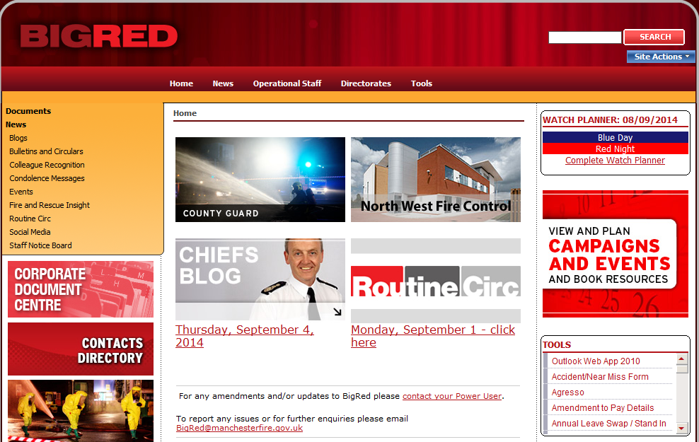

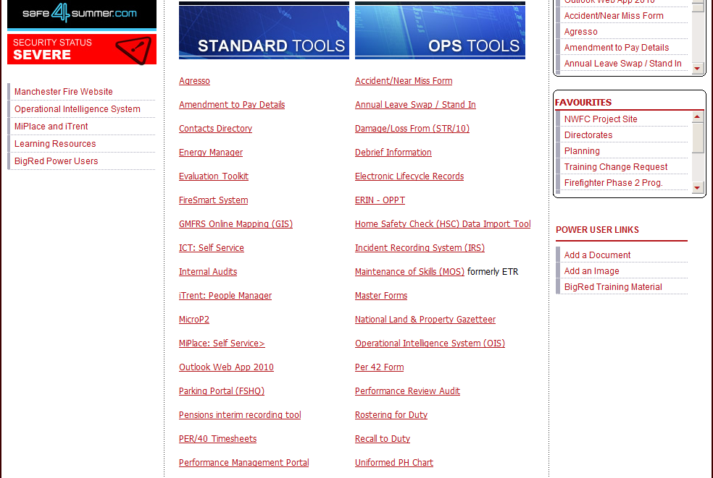

Under Standard Tools, click the Performance Portal link.

# How to Use the System

## Home Page

The Home Page is the first screen that you see when you access the system.

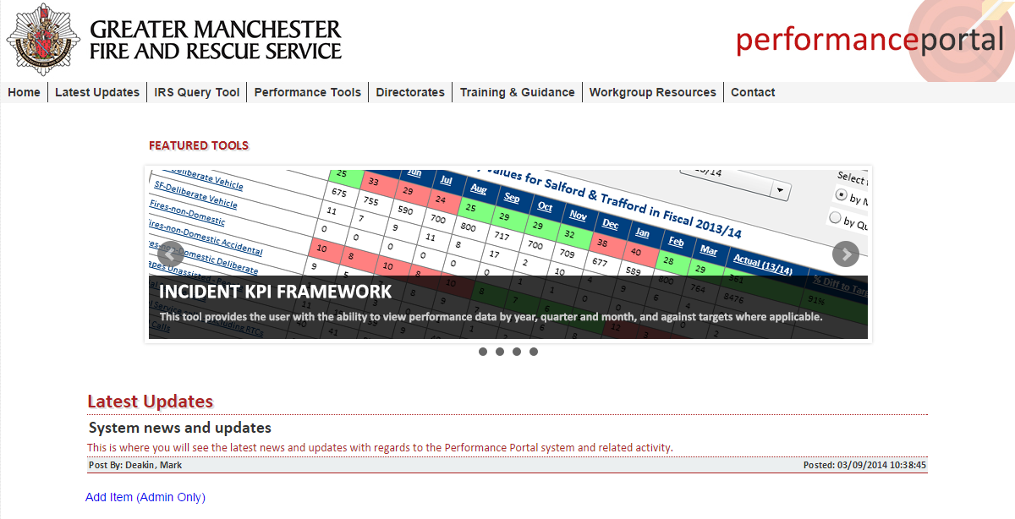

From here you can access each of the dynamic dashboards, as well as other useful tools/resources.

* Some functions are currently under development and will be available in future phases.

When you hover over any of the available menus, the relevant information/links will display directly below.

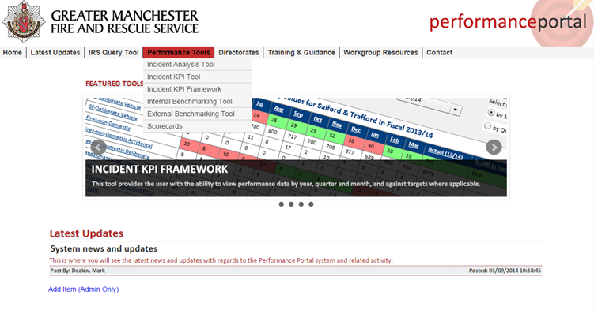

On the Home Page you will also find any news and updates regarding the system, details of who to contact should you require any help or assistance, and links to the associated training materials.

To return to the Home Page from any of the dashboards, you will need to click  icon.

* Please be aware that using the ‘Back Arrow’ within Internet Explorer will not work.

## Corporate Scorecards

The Corporate Scorecards show performance against all corporate performance indicators aligned to our 21 delivery goals at a variety of levels, from Organisational performance to Area, Borough and Station.

The dashboard can be accessed from the Performance Tools menu on the Home Page.

Below is the default view of the Corporate Scorecards dashboard.

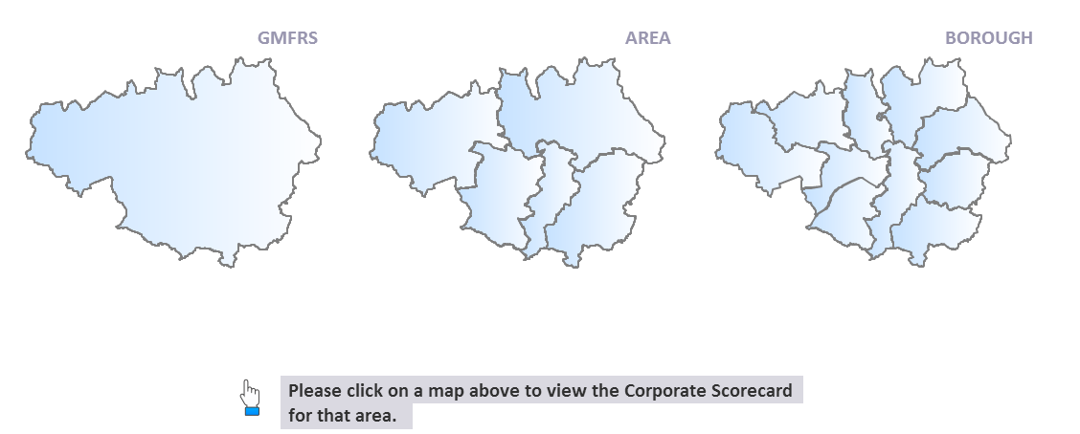

You would simply click on one of the relevant maps, to view that level of performance.

For this example I have selected the GMFRS map to view performance at an Organisational level. Here is where you choose your specific criteria.

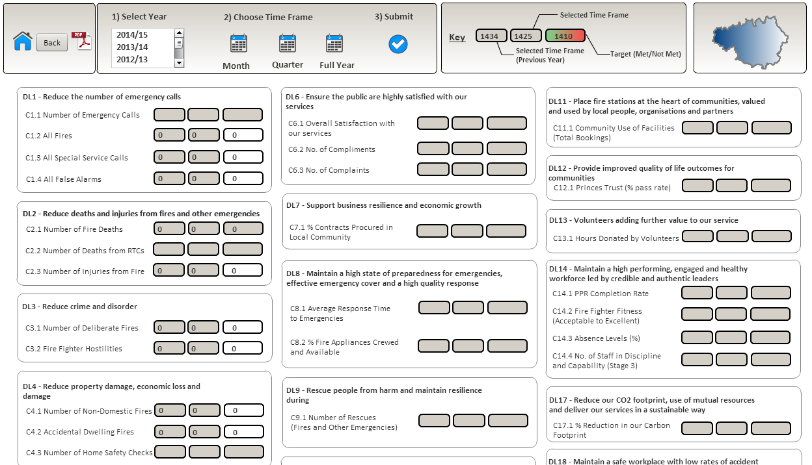

Once selected you click  to submit.

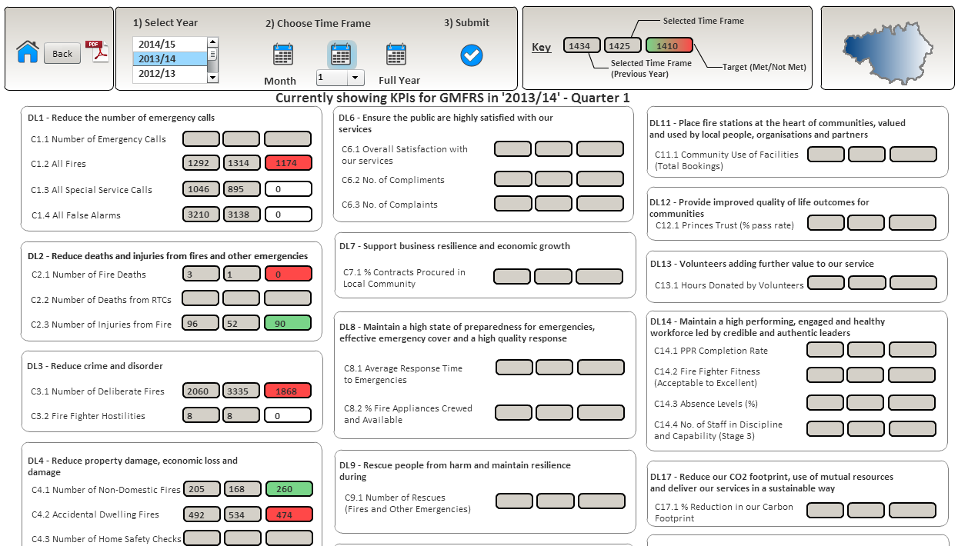

The dashboard will then be populated with information based on your specified criteria.

* Please be aware that some KPI’s will not currently be populated as they are in development.

The Key 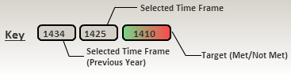 explains what the data displayed relates to. Where there is a target, these will show either red or green depending on whether the performance indicator is on or off target. If there isn’t a target these will be shown in white.

Where a measure has data attached to it, you can click on it and drill down to view further analysis of the data. For this example I have selected ‘c4.2 Accidental Dwelling Fires’.

The following table will be populated, showing performance against the chosen measure at various levels.

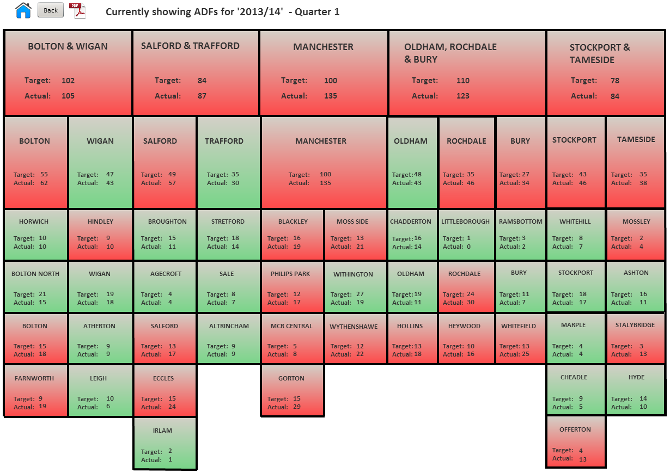

To return to the Home Page click 

## Emergency Response Tool

The Emergency Response Tool is a response analysis tool designed to provide Emergency Response Teams and Managers with the capability to interrogate things such as speed of response, Incident types responded to and also the equipment used at Incidents.

The dashboard can be accessed from the Directorates menu on the Home Page.

Below is the default view of the Emergency Response dashboard.

Here is where you choose your specific criteria.

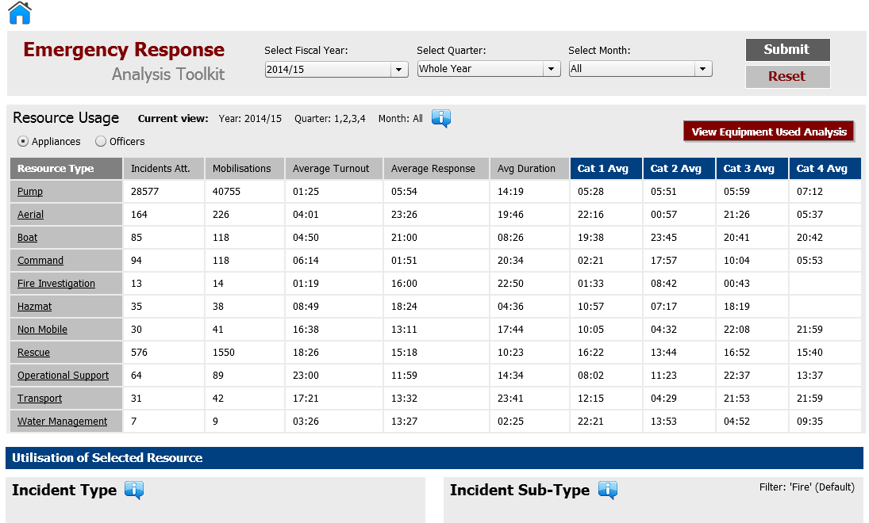

Once you have made your selections from the list of options. Click . The screen will then refresh with information based on your specified criteria.

The **‘Current view’** shows what is being displayed.



The chart displays the various Resource Types, along with some Statistics and Key Performance Indicators.

If you need further clarity of the data, you can find further information by hovering over the  where ever you see it displayed.

You can also see what equipment has been used at Incidents. Click 

The following screen will display:

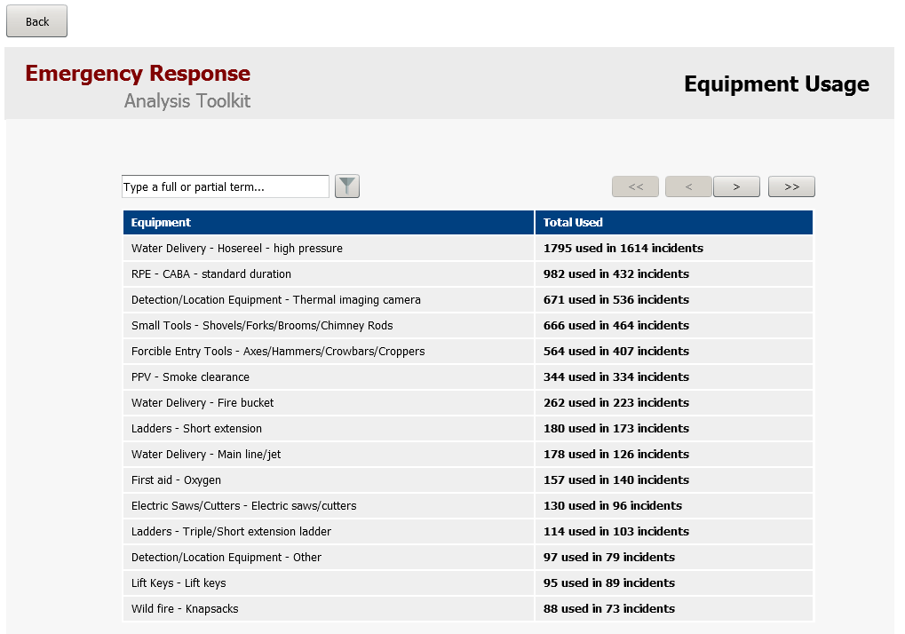

Here you can see what equipment has been used, how many times it’s been used and within how many Incidents. The Chevrons at the top of the screen allows you move forwards and backwards through the list.

You can also search for a particular equipment type using the search function. For this example I have typed ‘first aid’ and then clicked the filter icon. 

The screen will refresh and list the equipment that was searched for.

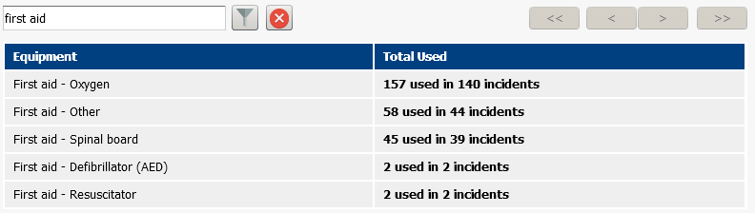

Click  to remove the filter. Click  to return to the previous screen.

For each type of Resource, you can click on it to view further analysis of the data.

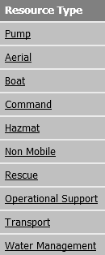

For this example I have clicked on ‘Pump’. You will see that the dashboard will now update.

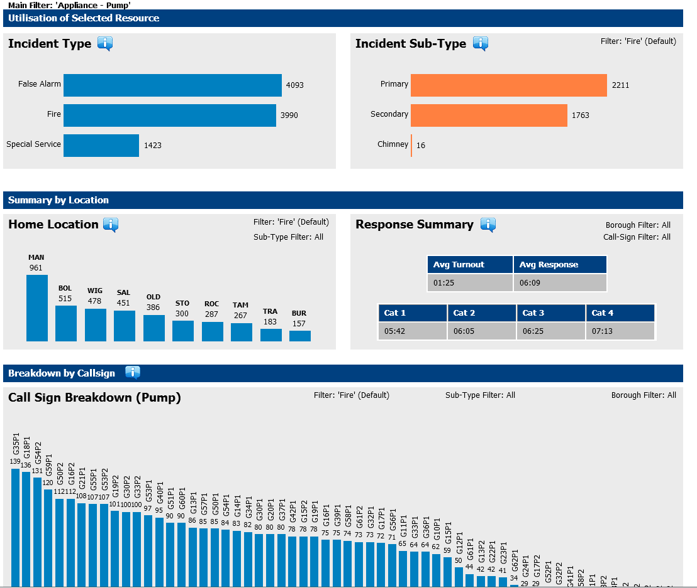

The Incident Type of ‘Fire’ has been chosen by default but can be amended.

For example if I clicked onto the Incident Type ‘False Alarm’

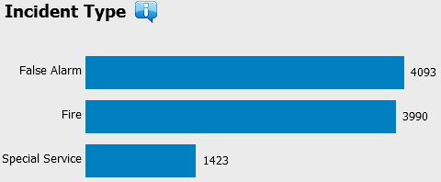

The dashboard will dynamically update all areas based on your selection. You can then drill down even further by clicking on a specific Incident Sub-Type. E.g. FADA

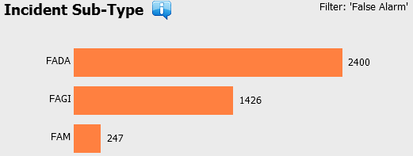

Again the Information will automatically refresh and you can see where filters have been applied.

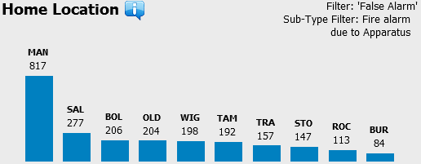

You can also see a further breakdown by Borough, by clicking on the relevant bar on the chart. Both the ‘Response Summary’ and ‘Call Sign Breakdown’ information will update.

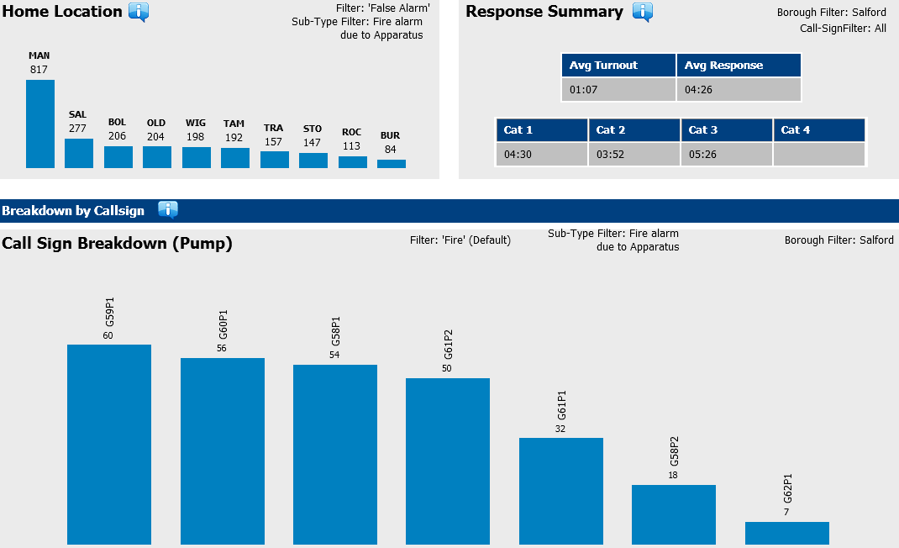

As well as viewing the Appliances used within that specified time frame, you can also see a list of Officers by clicking on the radio button. 

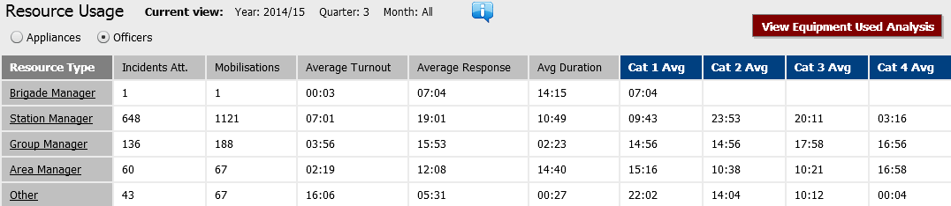

Just like Appliances you can click on any to view a further breakdown.

For this example I have clicked on ‘Station Manager’

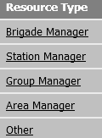

The dashboard will update to display those mobilisations made by ‘Station Managers’ for that time period displayed by Incident Type.

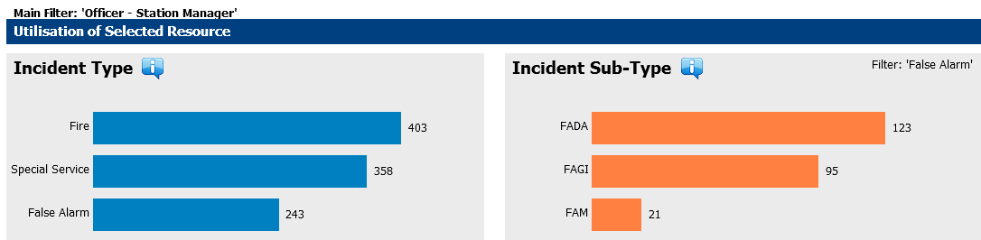

You can see how it applies the last filter i.e. False Alarms in this case. This can be changed by clicking on any of the other Incident Types.

At any point of time you can ‘Reset’ the data on the dashboard by clicking 

To return to the Home Page click 

## Incident Analysis Tool

The Incident Analysis Tool provides a one stop shop for all relevant incident performance information and allows us to interrogate the data at various levels to gain a better understanding of our performance.

The dashboard can be accessed from the Performance Tools menu on the Home Page.

### Incident Analysis – Quick Stats

Here you have the option to filter by Fiscal Period or by Date Range

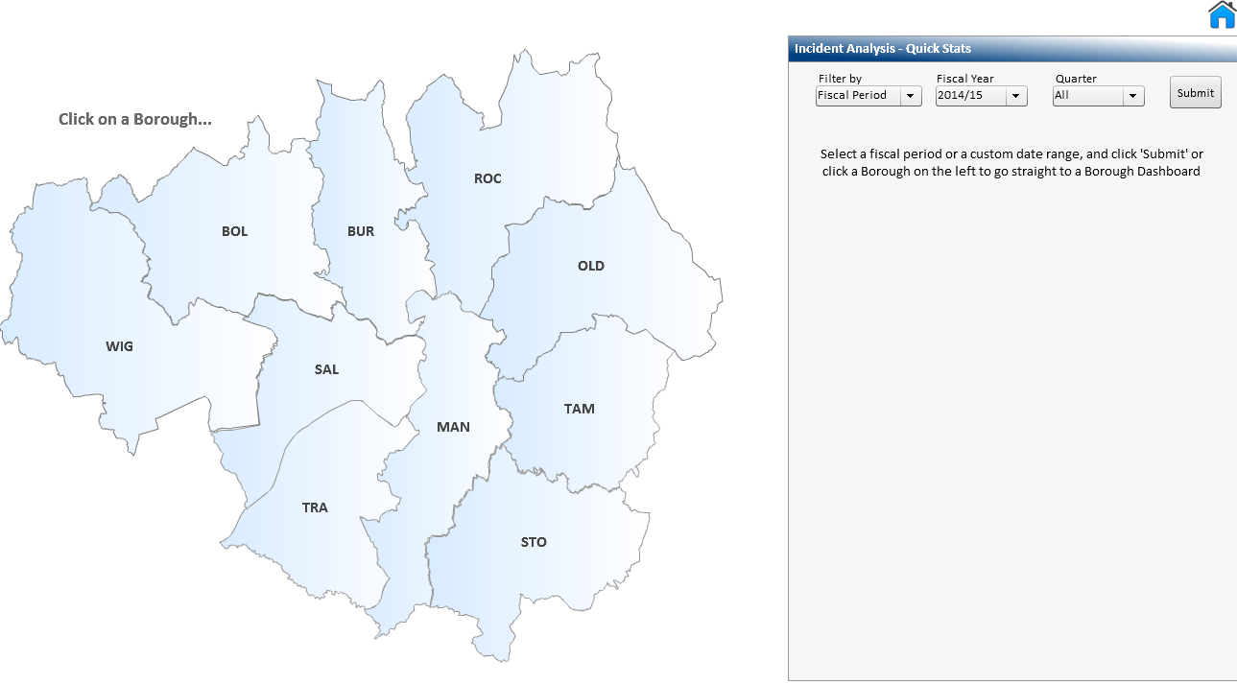

When you select Fiscal Period, you then need to choose a Fiscal Year from the list. If you want a full year then you would select the option ‘All’ alternatively you can choose a specific Quarter from the list, Q1, Q2 etc. You would then need to click the Submit button.

If you choose the option to filter by Date Range, the following fields will display:



Click the  icon in both the **From** and **To** fields as this will display a calendar from which you can select the required dates from.

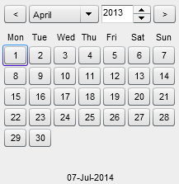

Navigate to the required month and year and select the date.

The fields will then be populated with the dates selected. You would then need to click 

You will be presented with the following chart, displaying the number of Fires, Special Services and False Alarms based on the criteria you specified.

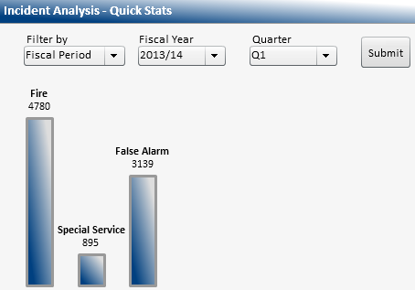

You can drill down further by clicking on the relevant bar.

For this example I have selected Fire.

The system will then provide further analysis.

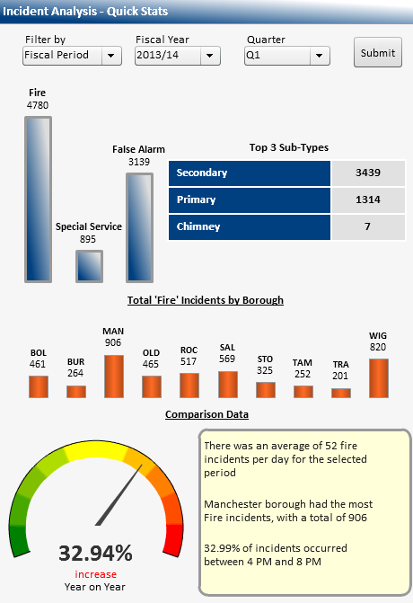

2

1

4

3

1. The top 3 subtypes of Fire.
2. The total Fire incidents by Borough.
3. The dial gives us a visual representation of the performance, compared to the same period the previous year.
4. The text box provides us with some basic analysis about the chosen incident type.

### GMFRS Performance Overview

Once you have submitted your query and the graph has displayed, the following button will be available at the bottom of the screen  Click the button to access the dashboard. The following will display.

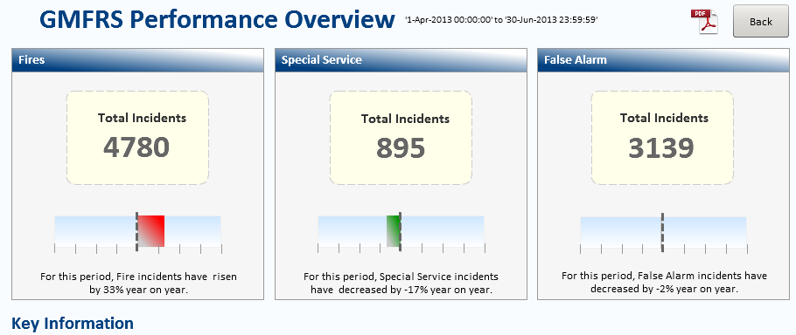

The dashboard allows us to view and analyse performance at a Corporate level. You will see the number of Fires, Special Services and False Alarms for the chosen period, along with a comparison to the same period the previous year.

To analyse the data further, you would simply click on the Incident Type Link.



For this example I have selected Fire.

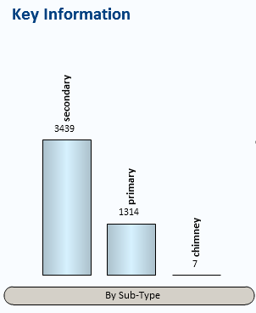

The chart shows us the total number of Fires for the top 3 subtypes. We can drill down further into the data by clicking on the relevant bar. For this example I have selected secondary.

The system will then provide us with a breakdown by Category and by Borough.

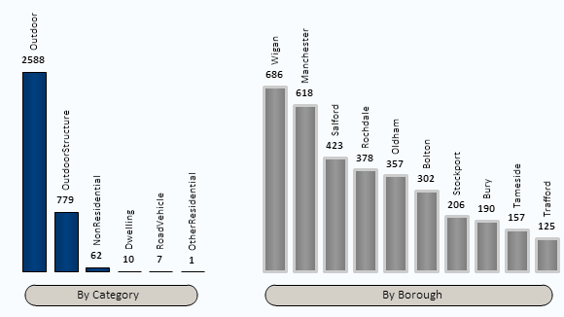

At the bottom of the dashboard there is also further information for us to see.

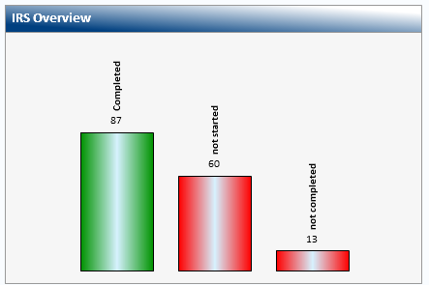

The IRS Overview shows the number of incident records which have the status of Completed, Not Started or Not Completed.

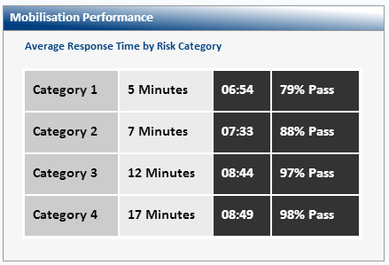

The Mobilisation Performance displays the Average Response Time and percentage pass rate by Risk Category. This is for the first pump only.

Click  to return to the previous screen.

### Borough/Station/Watch Performance

To access the Borough dashboard you would need to click on the Borough on the map.

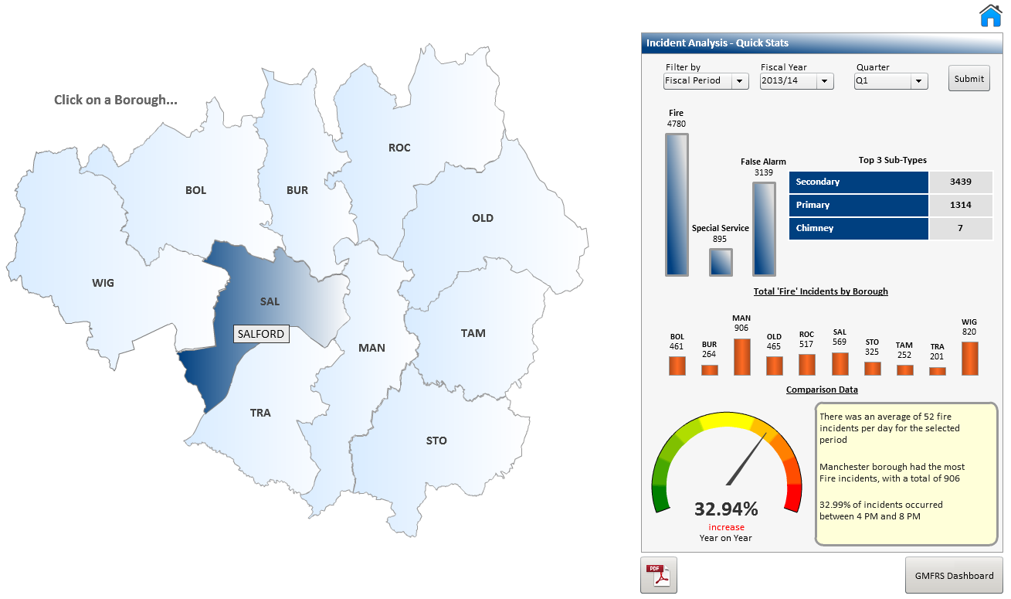

For this example I have selected Salford.

You will be presented with the following screen.

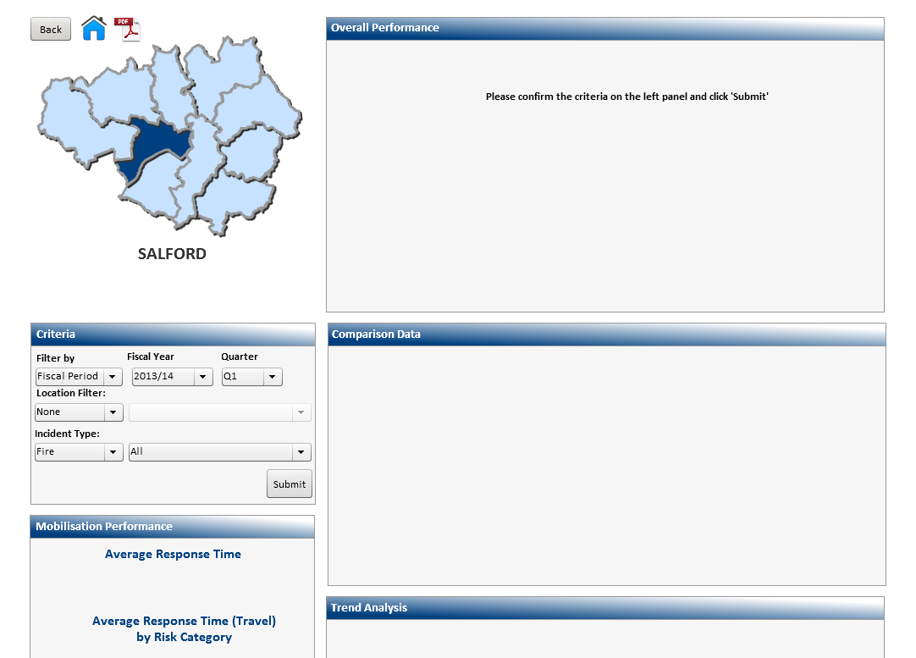

If you had used the **Incident Analysis – Quick Stats** then the criteria that you had specified would automatically be pulled through.

Click  to confirm the criteria.

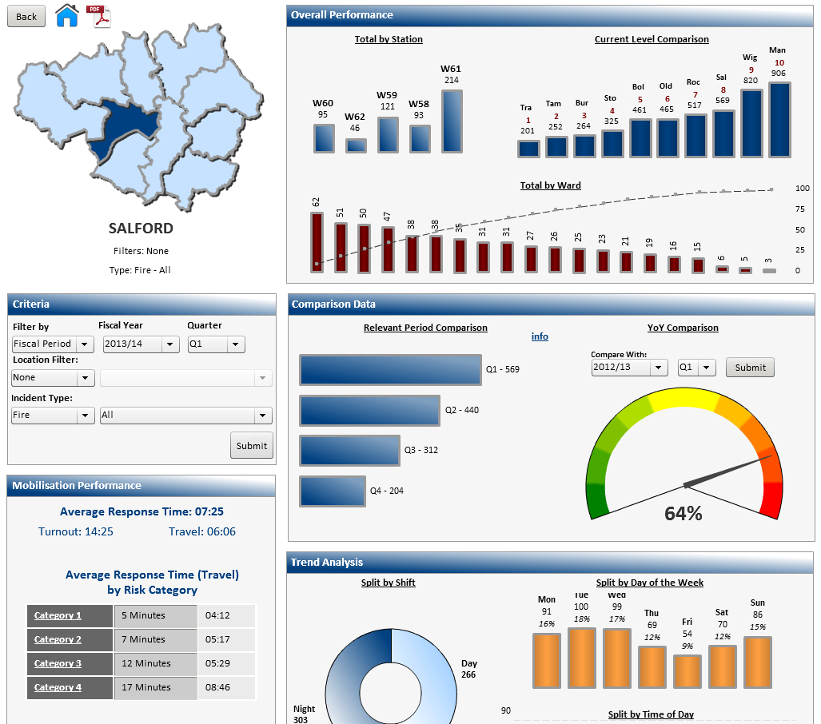

The dashboard will then be populated with information based on your specified criteria.

You may wish to analyse this data further, e.g. to look at a specific Fire Type. To do this you would need to apply a filter.

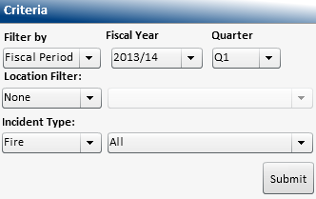

Click to display the list of Fire Types

For this example I have selected ‘Primary – All’

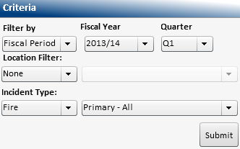 Then click 

The dashboard will now display the amended criteria.

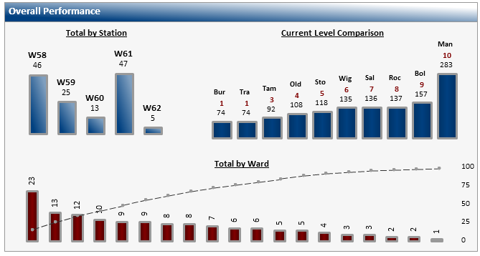

3

2

1

1. Here we can see the total number of all Primary Fires by Station.
2. The Current Level Comparison gives us the total number of all Primary Fires by Borough ranked in order from the lowest to the highest.
3. The pareto chart displays the total number of all primary Fires by Ward. (You would need to hover over the bars to display the Ward names). The chart shows the Wards with the highest number of incidents first, as well as the percentage number of incidents in a ward. This helps us to focus on any improvement activity on the Wards with the highest percentage of incidents.

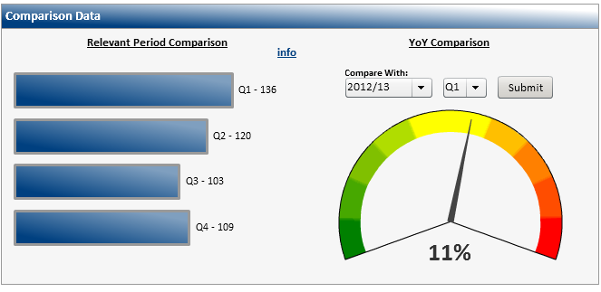

2

1

1. The information displayed within this chart, is based on the initial data selected. (In this example the total number of all Primary Fires for 2013/14 Q1 for Salford Borough). It also displays data based on the same criteria for the other quarters within the same year e.g. 2013/14
2. The dial gives us a visual representation of either a percentage reduction/increase in the number of incidents compared to the same period the previous year.

* You may change the criteria you specified at any time by changing the options within the criteria section and clicking submit.

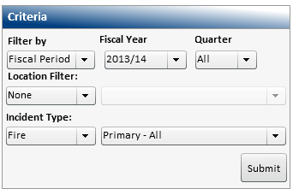 Selecting ‘All’ will display the full year.

Click  to confirm the criteria.

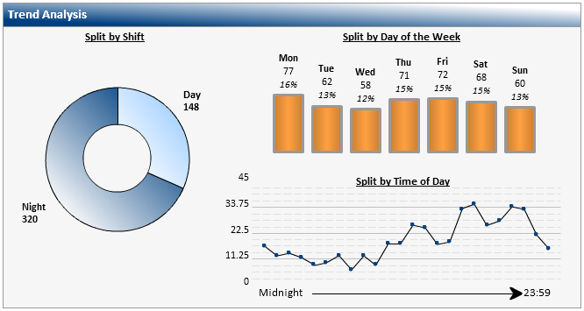

2

3

1

1. This display the total number of all Primary Fires for 2013/14 split by shift (day/night).
2. The chart displays those same numbers of incidents split by the day of the week when they occurred.
3. This graph shows us the number of incidents that occur on each hour of the day. (You would need to hover over the dots to display the actual times). By clicking on a particular day of the week on the above, the graph will change.

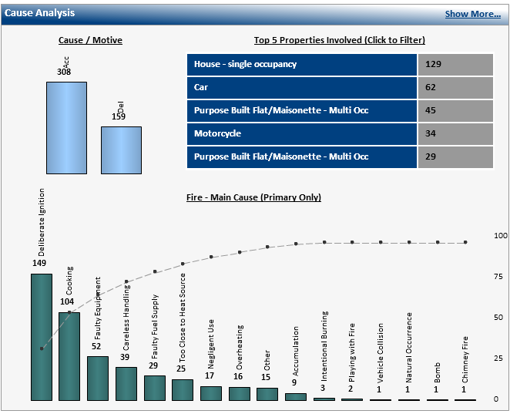

2

3

1

1. Here we can see the total number of all Primary Fires for 2013/14 split by motive (Accidental/Deliberate).
2. The table shows the same number of incidents split into the 5 top property types. (You are able to click on any property type listed and in doing so the data selected would be displayed).
3. The pareto chart displays the fire causation, showing the highest number first as well as the percentage number. This helps us to focus on any improvement activity on the causes with the highest percentage.

The system also allows us to analyse the data further, to do this you would need to click on the link  which will display a further breakdown.

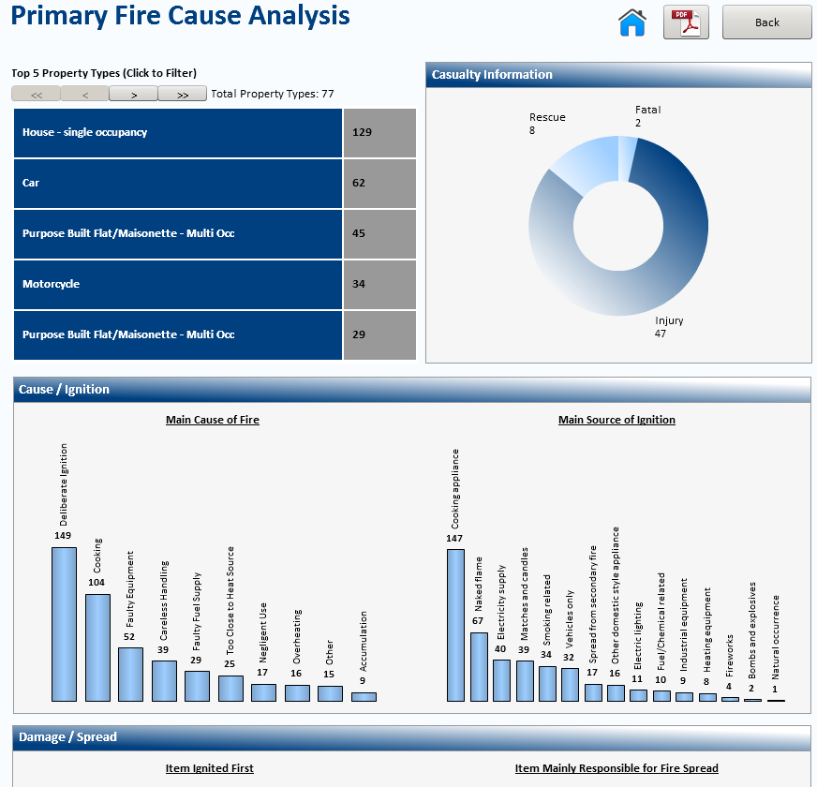

You can click on any property type listed and in doing so the data selected will be displayed.

The chevrons  at the top of the screen allow you to scroll forwards and backwards through the pages of data.

The remainder of the screen provides us with further analysis.

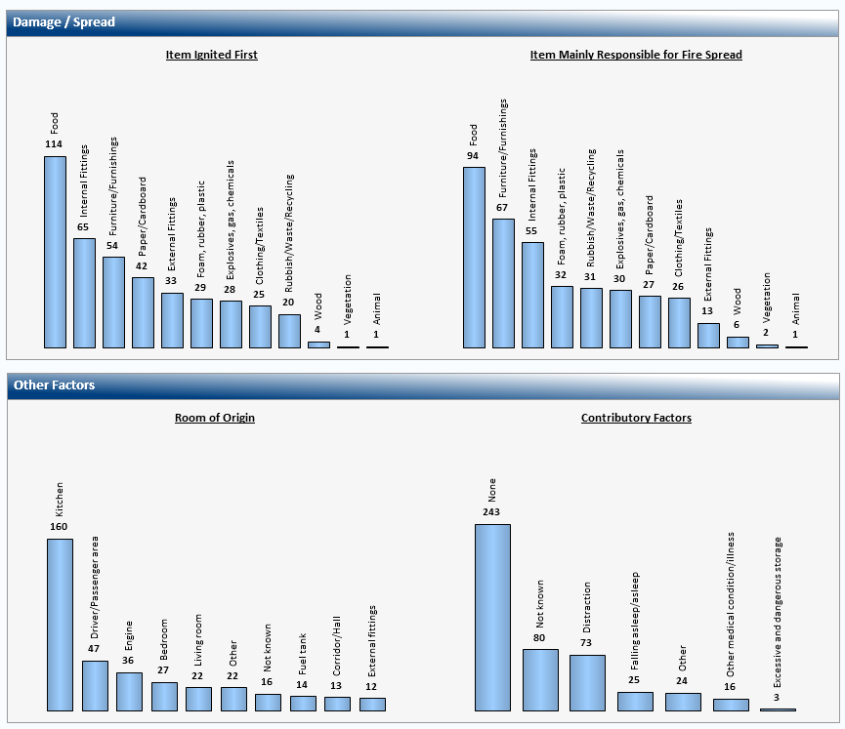

To return to the previous screen, you would need to scroll back up to the top of the screen. To go back to the previous screen click 

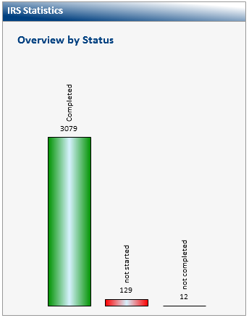

The IRS Statistics shows the number of incident records which have the status of Completed, Not Started or Not Completed.

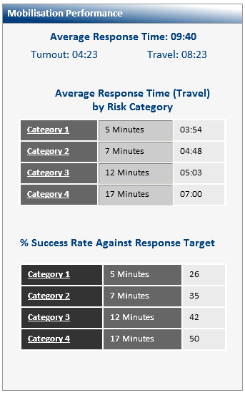

The Mobilisation Performance displays the Average Response Time by Risk category.

We can also see the percentage Success Rate against Response Targets.

As well as viewing performance at a Corporate and Borough level, the system also has the ability to enable you to view performance at Station level. To do this you need to include the Station into your criteria and click submit.

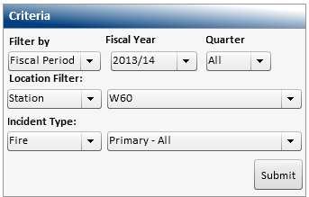

For this example I have selected Station – W60 (Agecroft)

The dashboard will refresh and the information displayed will now relate to the Station selected. In this example, Agecroft.

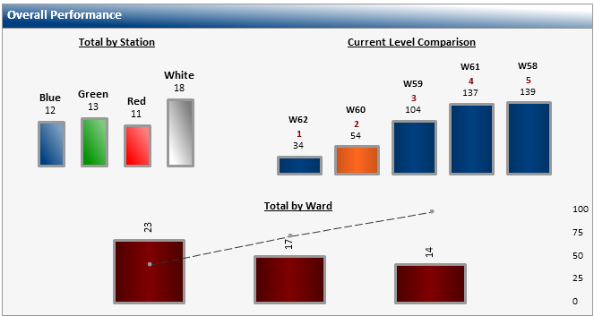

3

2

1

1. Here we can see the total number of all Primary Fires by Watch.
2. The Current Level Comparison, gives us the total number of all Primary Fires by Station, ranked in order from the lowest to the highest. You will see that the Station that you are currently looking at is highlighted.
3. The pareto chart displays the total number of all Primary Fires by Ward. (You would need to hover over the bars to display the ward names).

When the Station is selected, the Mobilisation Performance changes to include the ability to display mobilisation by Watch, by selecting from the dropdown list.



The remainder of the screen is as described earlier.

### Accidental Dwelling Fires Dashboard

The Accidental Dwelling Fires dashboard becomes available when this incident type is selected.

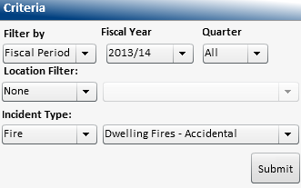

You would need to click on the link

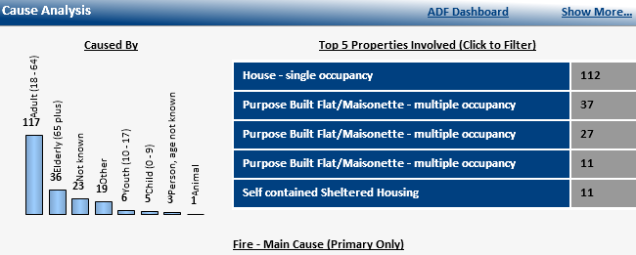

The dashboard allows us to quickly and easily analyse performance specifically for Accidental Dwelling Fires

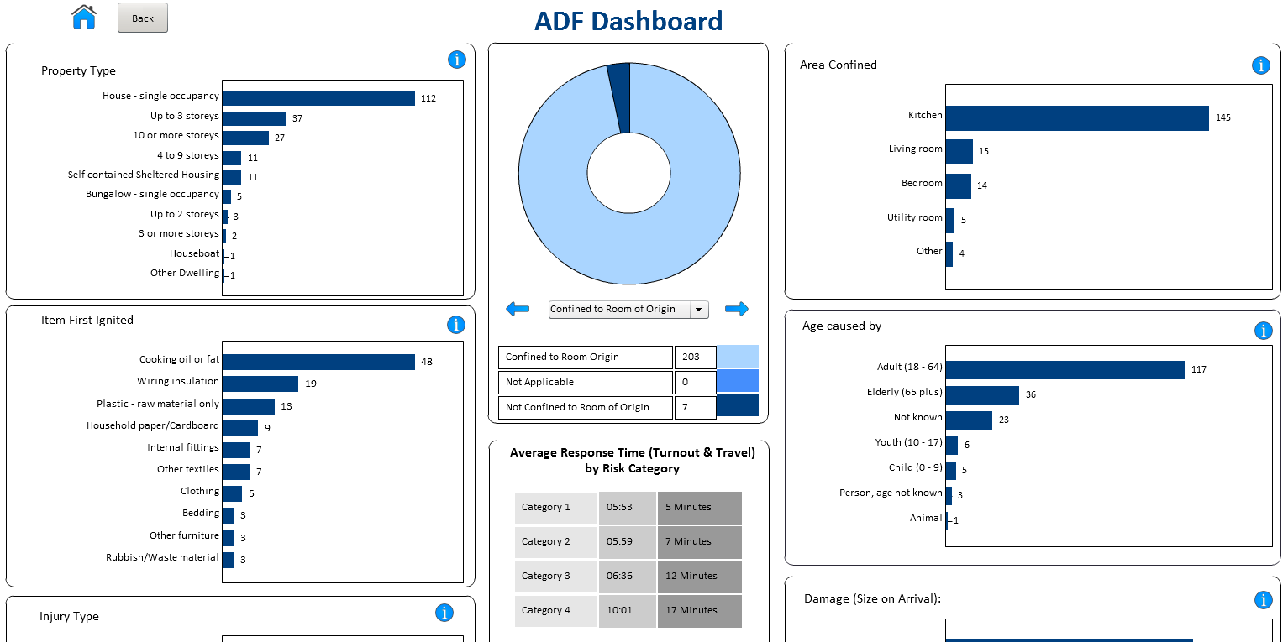

This is done using a variety of charts and pick lists with drill down functionality to help all round performance to be easily understood.

If you need further clarity of the data being displayed, you can find further information by clicking  wherever you see it displayed.

To change the criteria, click the dropdown arrow and select from the list.

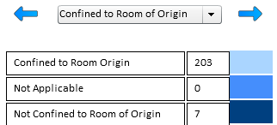

The dashboard will refresh and display data based on the option selected.

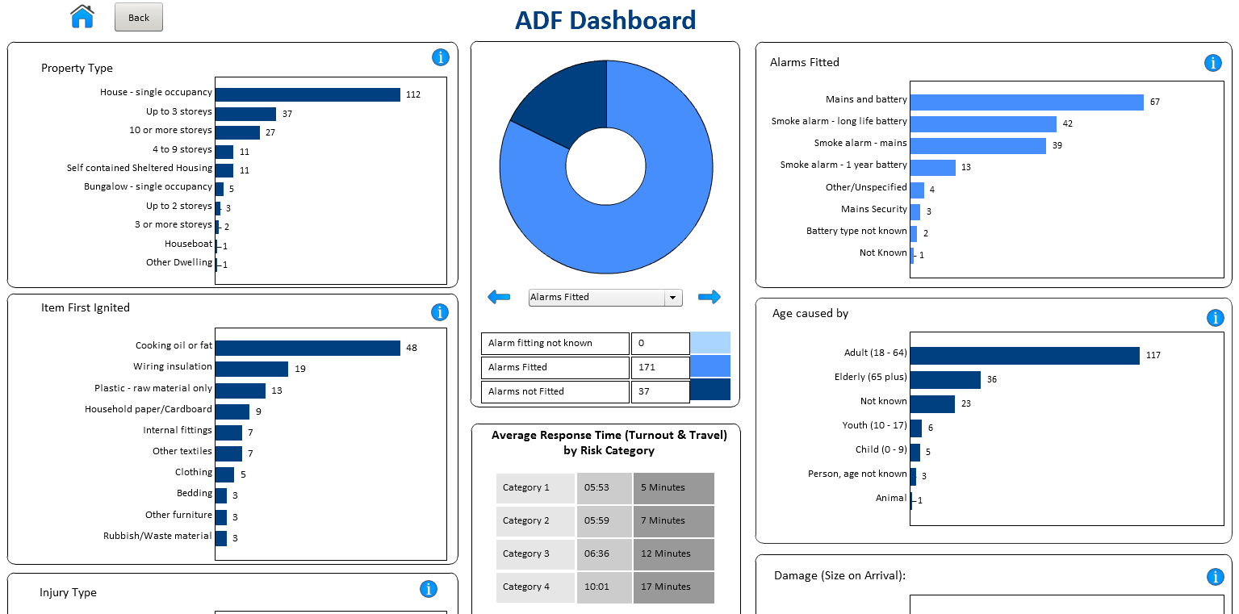

* Some of the sections may contain more than one level of detail when using the drill down facility.

To return to the Home Page click 

## Incident KPI Tool

The Incident KPI Tool provides a snapshot of performance against targets (where applicable) at Corporate, Area, Borough and Station level.

The dashboard can be accessed from the Performance Tools menu on the Home Page.

Below is the default view of the Incident KPI Tool dashboard

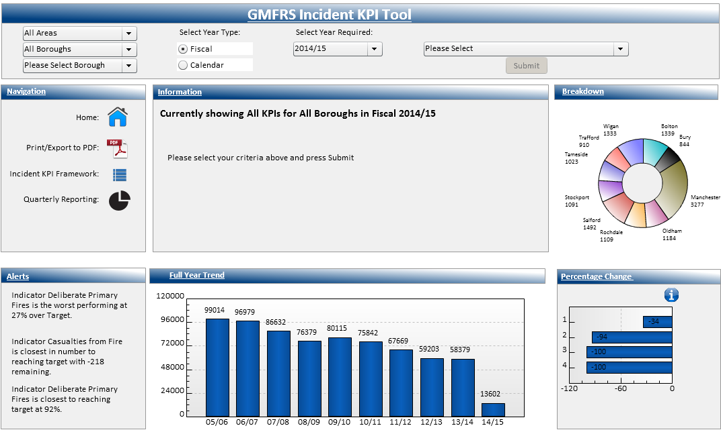

To continue to look at performance at a Corporate level, you do not need to change these fields.

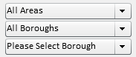

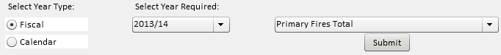

You have the option to select either a Fiscal Year or a Calendar Year. Select the required year and KPI from the list of options. Click 

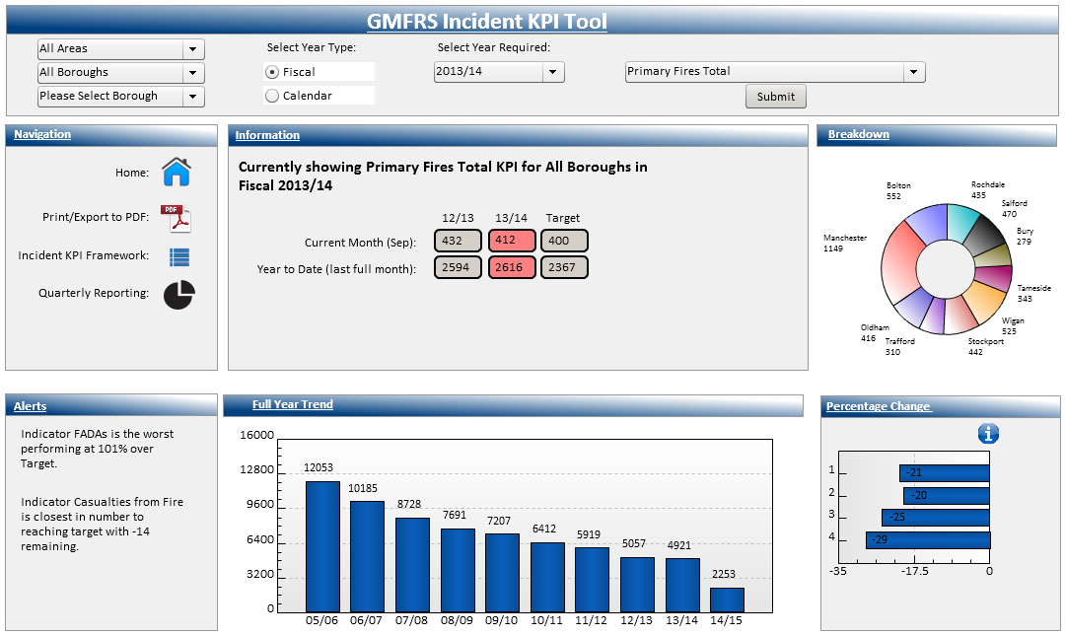

The dashboard will refresh and display data based on the criteria specified.

If you need further clarity of the data being displayed, you can find further information by clicking on the  wherever you see it displayed.

To display information for an Area, simply select the Area from the dropdown list.



Click  as before, the dashboard will refresh and display data based on the criteria specified.

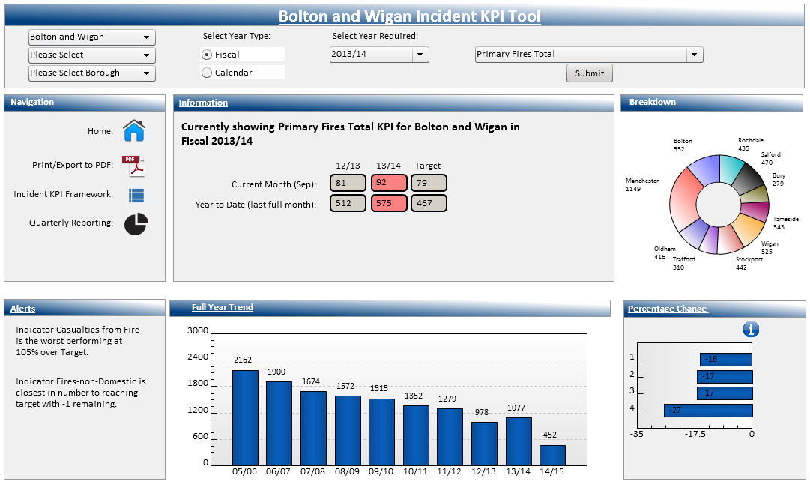

The title of the dashboard will also update. You will also notice that the dashboard has displayed even further data as I included an Area into the criteria.

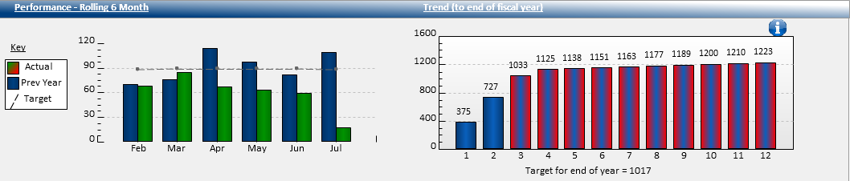

You can also view the information at a Borough/Station level. Click to select the Borough and Station from the dropdown lists. (You can just select a Borough).



Click  as before, the dashboard will refresh and display data based on the criteria specified.

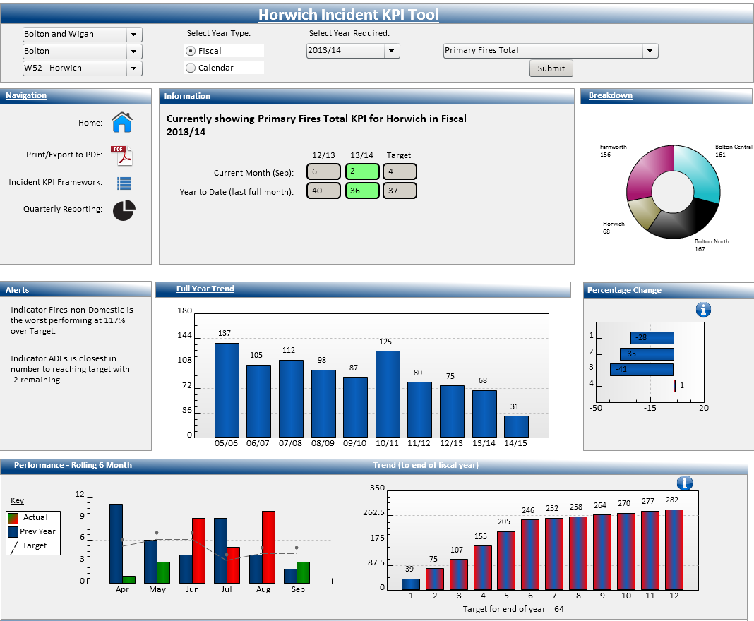

When you include a Borough and/or Station into your criteria, again the dashboard contains even further data.

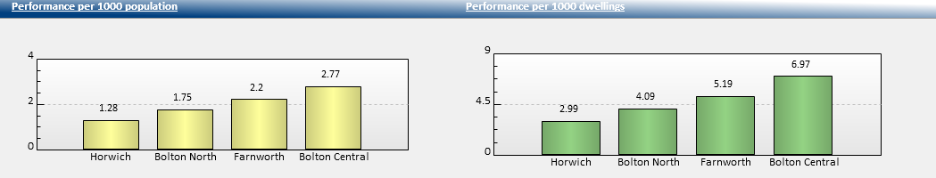

To return to the Home Page click 

## Incident KPI Framework Tool

The Incident KPI Framework Tool provides us with the ability to view performance per KPI by Year, Quarter, Month and against targets where applicable.

The dashboard can be accessed from the Performance Tools menu on the Home Page.

Below is the default view of the Incident KPI Framework Tool

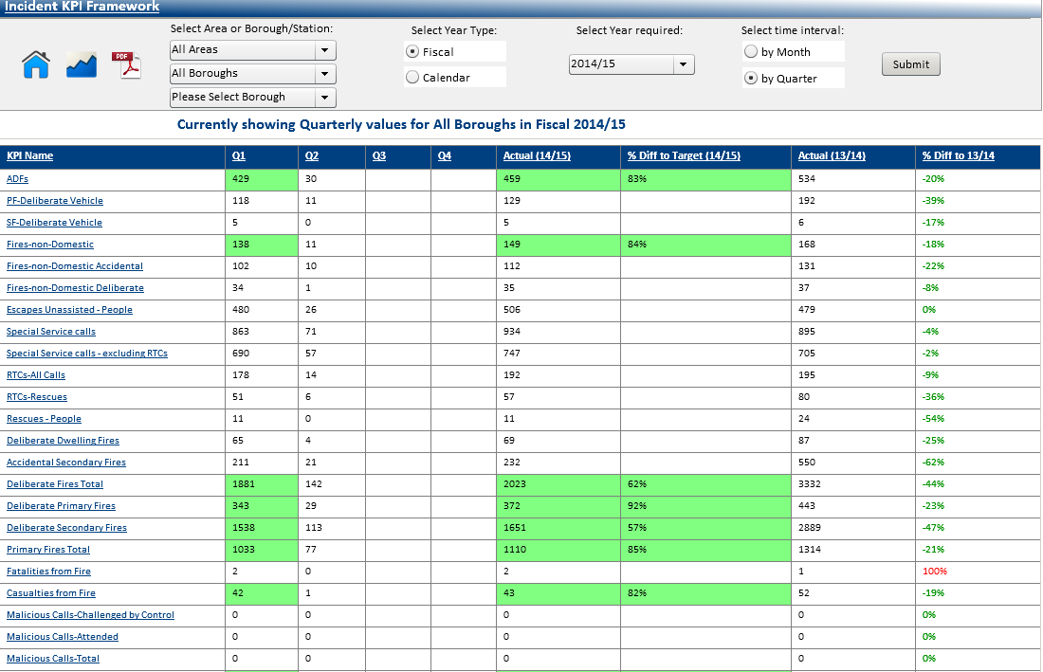

To continue to look at performance at a Corporate level, you do not need to change these fields.



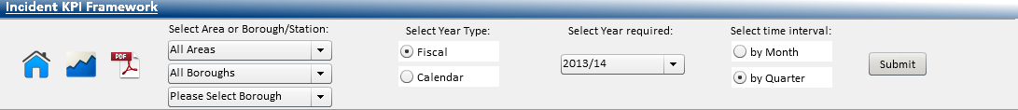

You have the option to select either a Fiscal Year or a Calendar Year. Select the required year. You also have the option to select to show information by month or by quarter.

Click 

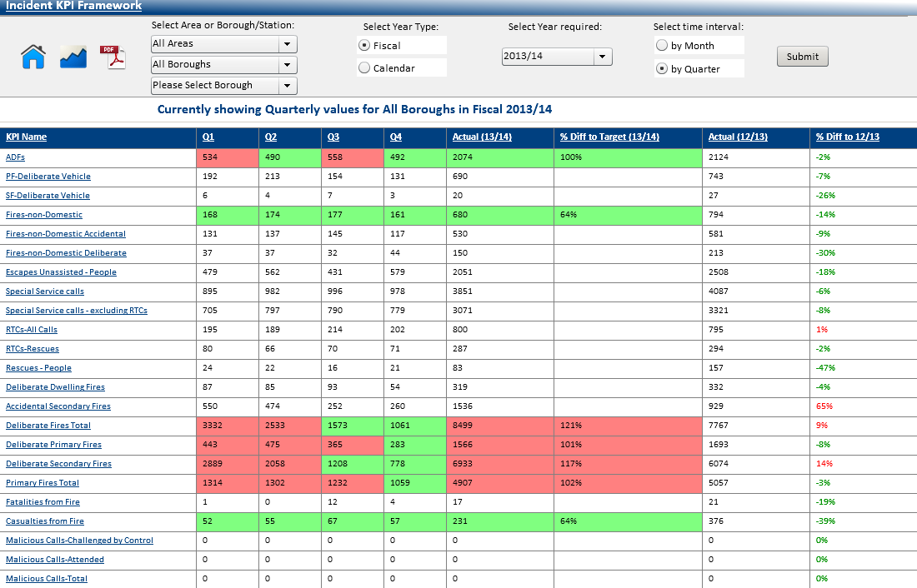

The dashboard will refresh and display data based on the criteria specified. You may need to use the scroll bar to the right of the screen to display the complete list of KPI’s.

To display performance information for an Area, simply select the Area from the dropdown list.

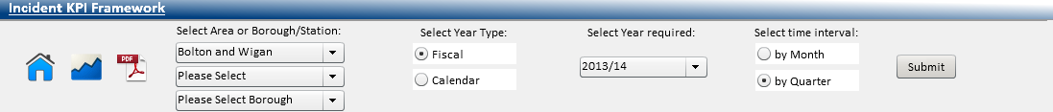

Click  as before, the dashboard will refresh and display data based on the criteria specified.

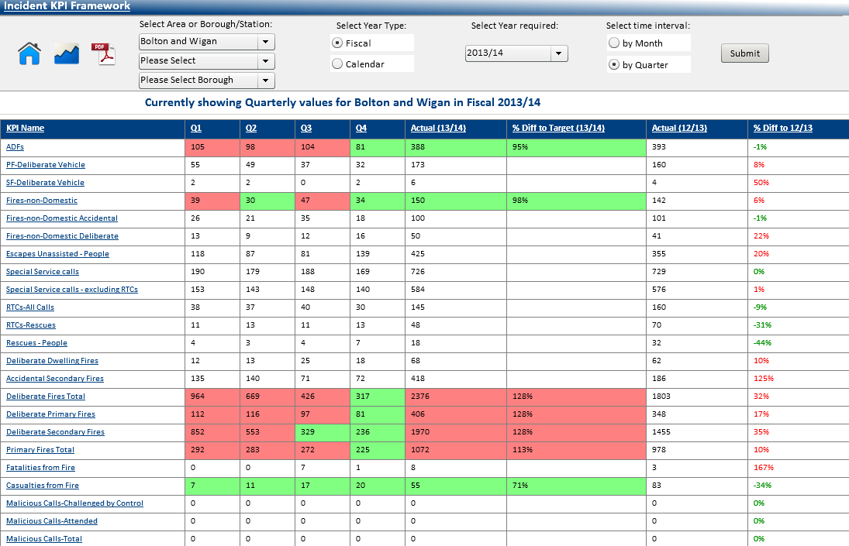

You can also view the information at a Borough/Station level. Click to select the Borough and Station from the dropdown lists. (You can just select a Borough)

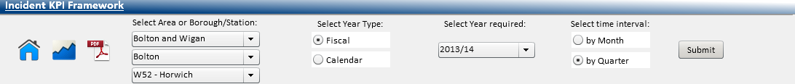

Click  as before, the dashboard will refresh and display data based on the criteria specified.

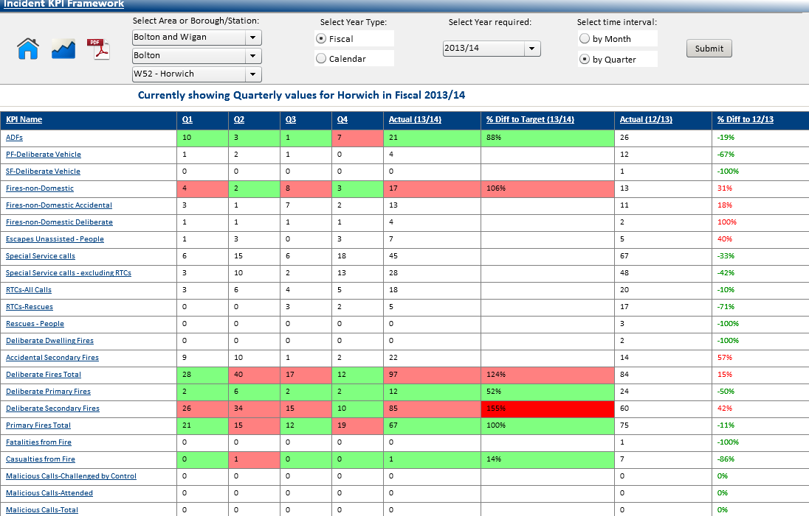

The KPI’s that have targets set against them will display **green** if within the target and **red** if over target. When you hover over any of the figures, it will display the **actual** target figure.

Example: 



Each of the KPI’s that are listed on the left hand side are hyperlinked. By clicking on the KPI it will take you to the **Incident KPI Tool** anddisplay the selected KPI, to allow further interrogation of the data.

The example below shows the display after selecting the **Fires–non-Domestic** **KPI**

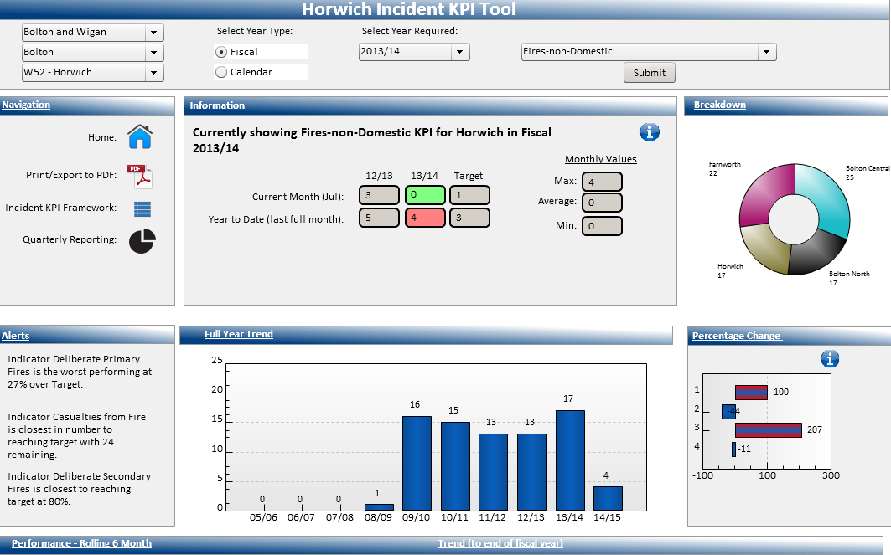

The criteria that you specified in the Incident KPI Framework Tool will automatically feed through and the relevant data will be displayed.

To return to the Home Page click 

## Incident Query Tool

The Incident Query Tool allows you to carry out a search of IRS where limited information about an Incident(s) is available.

You can find out how many Incidents have occurred at a particular address; search for keywords in the Narrative Log and you can also search for Incidents using a particular Officers Call Sign.

The dashboard can be accessed from the Performance Tools menu on the Home Page.

Below is the default view of the Incident Query Tool.

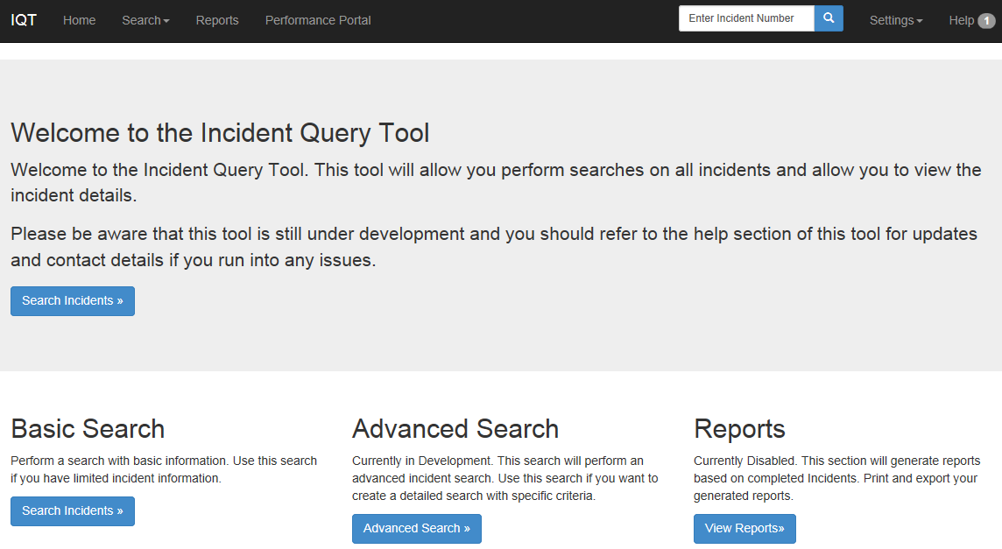

* Please be aware that the **Advanced Search** and the **Reports** are currently in development.

If you had the Incident Number you would simply type it in the box and click the search icon. 

If you don’t have an Incident Number you would need to click the  under Basic Search.

The top half of the screen is where you would enter your search criteria.

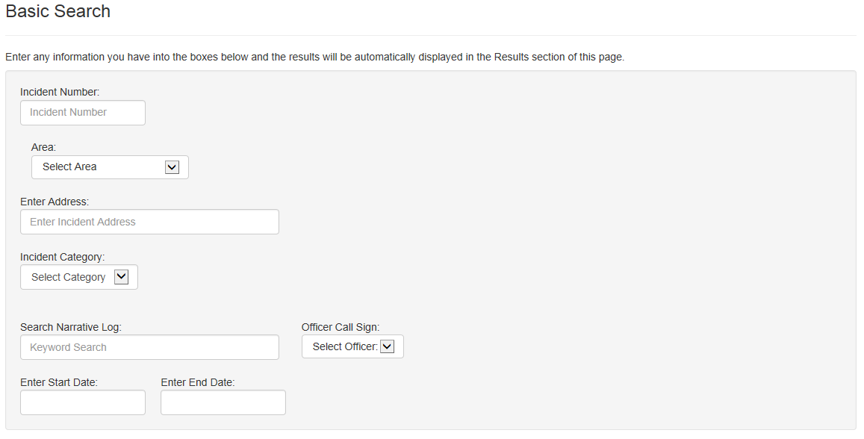

And the bottom half of the screen will display your list of results.

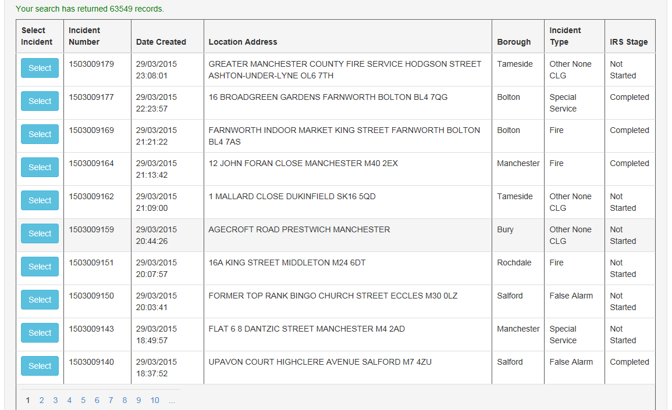

Where no criteria has been entered, as in this case, the system will bring back Incidents that took place in the last 2 years.

For this example I am going to search on an address ‘Cemetery Road’ (you can search on partial addresses)

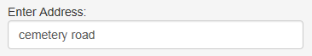

There is no Submit button on this tool. The search is instant; you just need to make sure that you have clicked out of the field, or pressed Enter.

You will see the list of results has now refreshed to display only those Incidents that match your criteria.

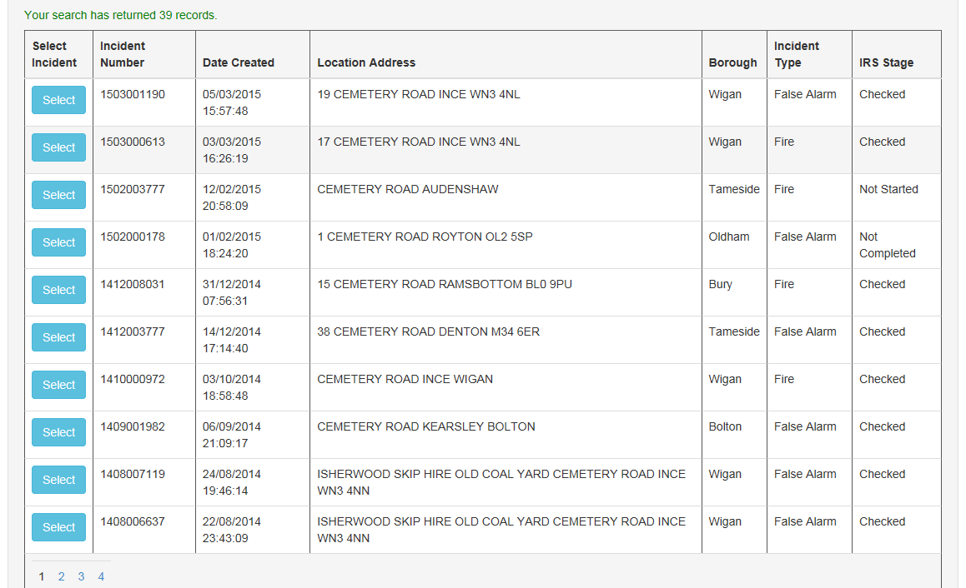

The system will display up to 10 Incidents per page, you would need to click on the page number to navigate through the list.

To refine your list of results even further you could include such things as, Incident Category, Date Range etc. For this example will include Station Area.

Click the dropdown arrow to select the Area from the list. The Borough pick list will then appear, click to select the Borough. The Station pick list will then appear, click to select the Station.

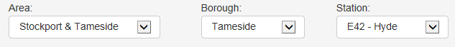

The list of results will be refreshed, and will now only display those Incidents for **‘Cemetery Road’** in the Station Area of **‘Hyde’**

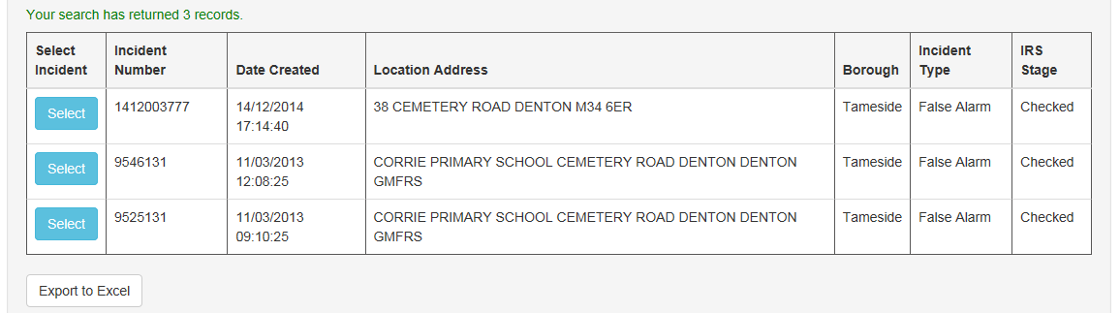

* To clear previous information, simply clear each of the fields used.

You can also search to display those Incidents where a particular Officer attended. Click the dropdown arrow to display a list of Officer Call Signs. For this example I have selected Call Sign **‘GA015’**

Again the screen will refresh and display those Incidents where Officer **‘GA015’** was in attendance.

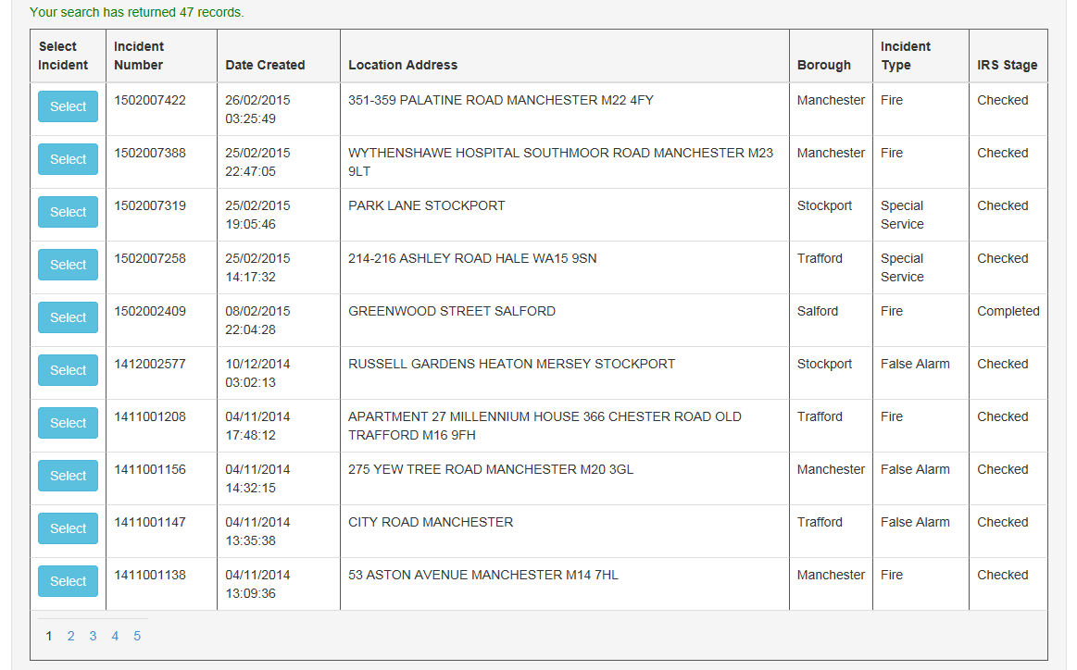

The Basic Search also allows us to display Incidents that contain a keyword(s) within the Narrative Log. For this example I will search for **‘Wheelie Bin’**



Again once I click outside of the field the screen will refresh and list those Incidents where the word **‘Wheelie Bin’** is recorded within the Narrative Log.

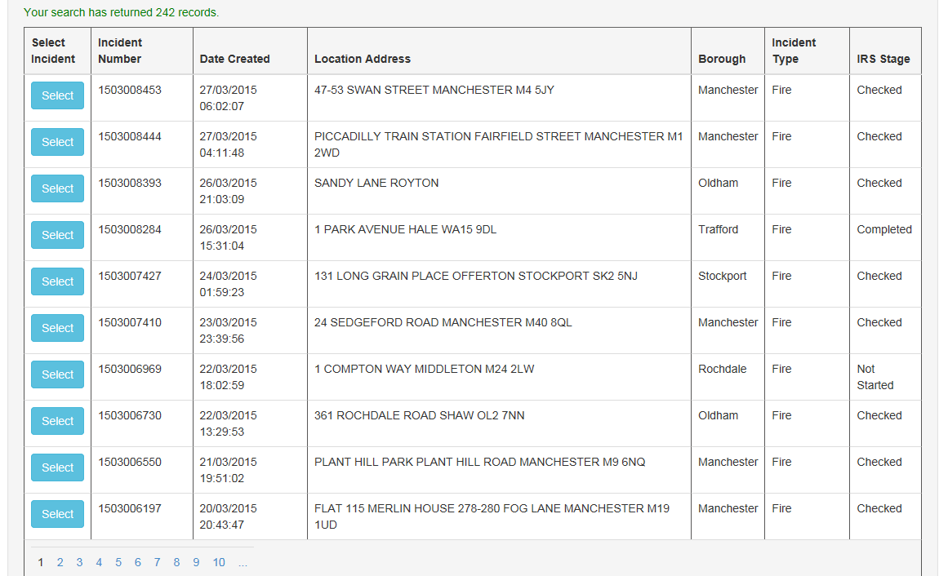

The Tool also allows us to export the list of results into Excel.

Click 

The following message will display:



Click  to open Excel.

You will get the following message:



Click 

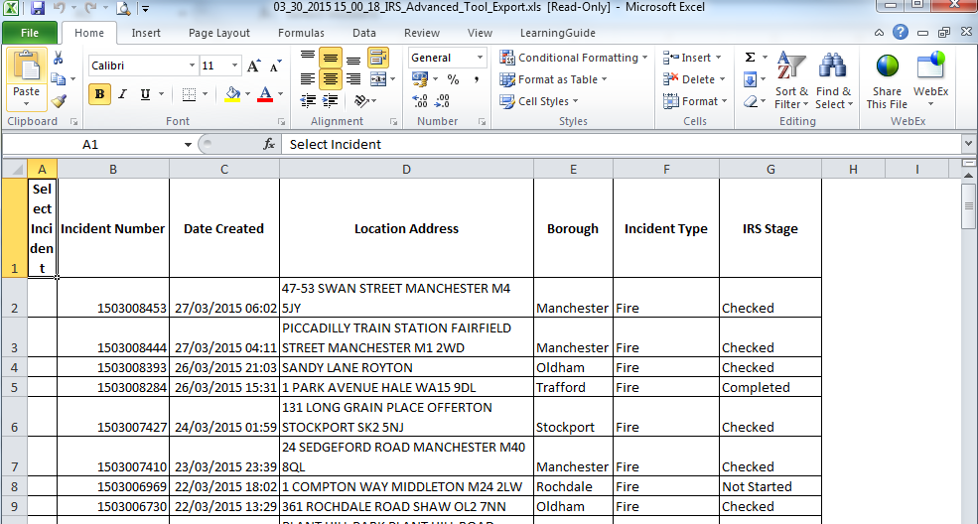

Excel will open, you can then apply formats or filters in the usual way. Click  to close. You will be returned to the previous screen.

To get an overview of a particular Incident, you would need to click on the corresponding Select button.



You will be taken to the Incident Overview screen:

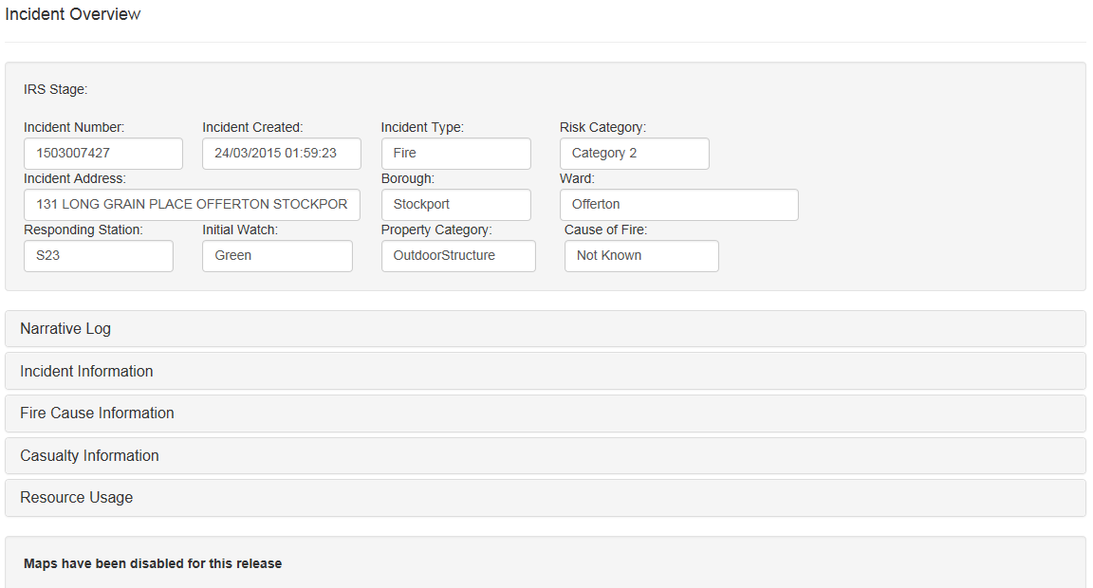

The information here can be expanded by clicking on the relevant title. For this example I have clicked on the **Narrative Log title.**

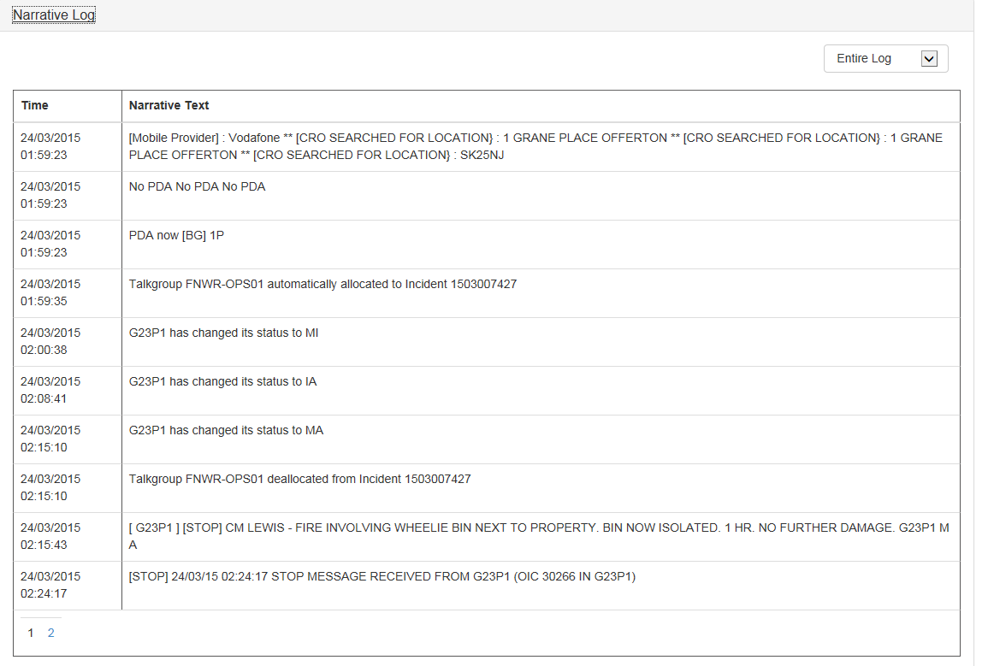

As you can see using this example, this is why this Incident was displayed earlier when we searched for **‘Wheelie Bin’** as a keyword. Click the title again to collapse the information.

To the top left of the screen you will see the  Click it to display the menu.

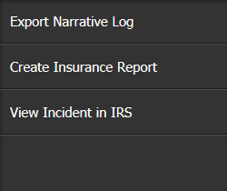

* Please be aware that the ‘Create Insurance Report’ will only be available to the Data Management Team.

The Tool enables us to export the Narrative Log into Word. Click  the following message will display:



Click 

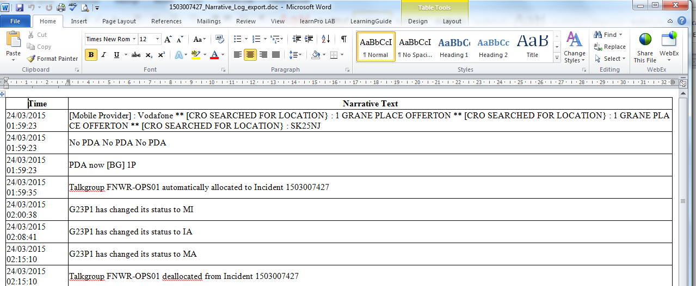

Word will open, you can then format or print in the usual way. Click  to close. You will be returned to the previous screen.

You will be asked the following:

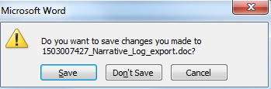

Choose the desired option.

You can also view the Incident in IRS. Click  IRS will open and you can view the details in the usual way.

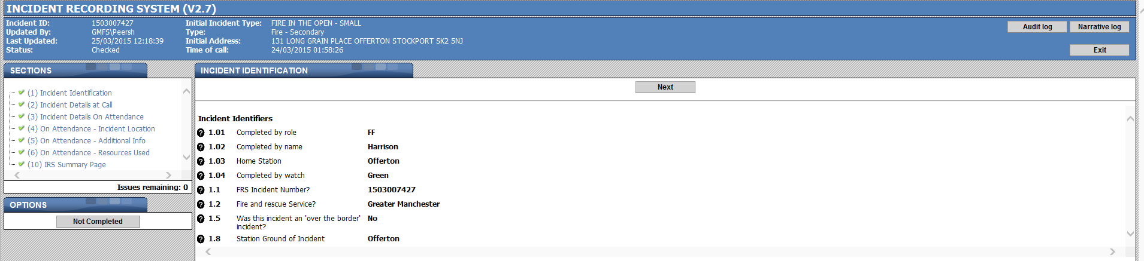

Click  You will be returned to the previous screen.

To go back to the Search screen, at the top of the screen, click Search, then Basic Search.

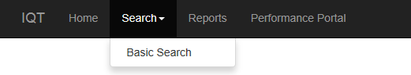

You will be returned to the Basic Search screen.

To return to the Performance Portal Home page. Click Performance Portal.



## Internal Benchmarking Tool

The Internal Benchmarking Tool allows Stations to monitor their relative performance against the three Station Families, plus an option of selecting which Stations they want to benchmark with using the Compare Me Tool. Measures are based on Incident and Response KPI’s.

The dashboard can be accessed from the Performance Tools menu on the Home Page.

Below is the default view of the Internal Benchmarking Tool.

Here is where you choose your specific criteria.

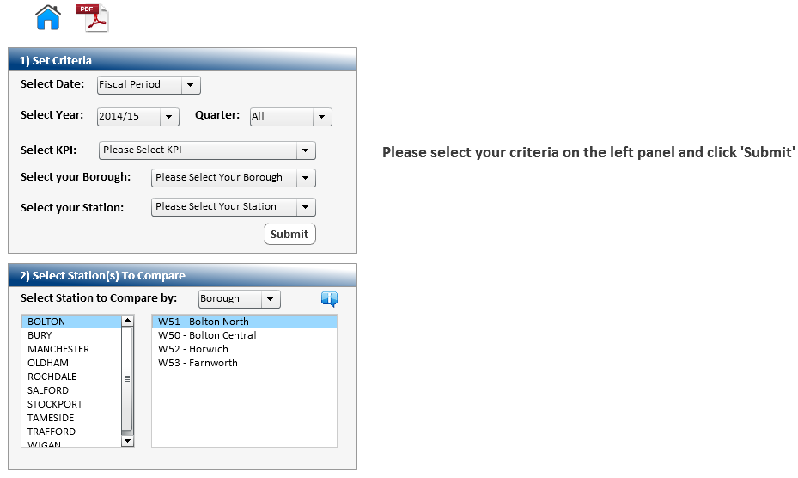

When you select Fiscal Period, you then need to choose a Fiscal Year from the list. If you want a full year then you would select the option ‘All’ alternatively you can choose a specific Quarter from the list, Q1,Q2 etc.

If you choose the option to filter by Date Range, the following fields will display:



Click the  icon in both the **Date From** and **Date To** fields as this will display a calendar from which you can select the required dates from.

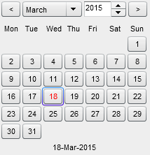

Navigate to the required month and year and select the date.

You then need to select the KPI, Borough and Station from the dropdown lists.

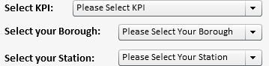 Click 

For this example, I have selected ADFs KPI, Salford Borough and Agecroft Station.

The dashboard will then be populated with information based on your specified criteria.

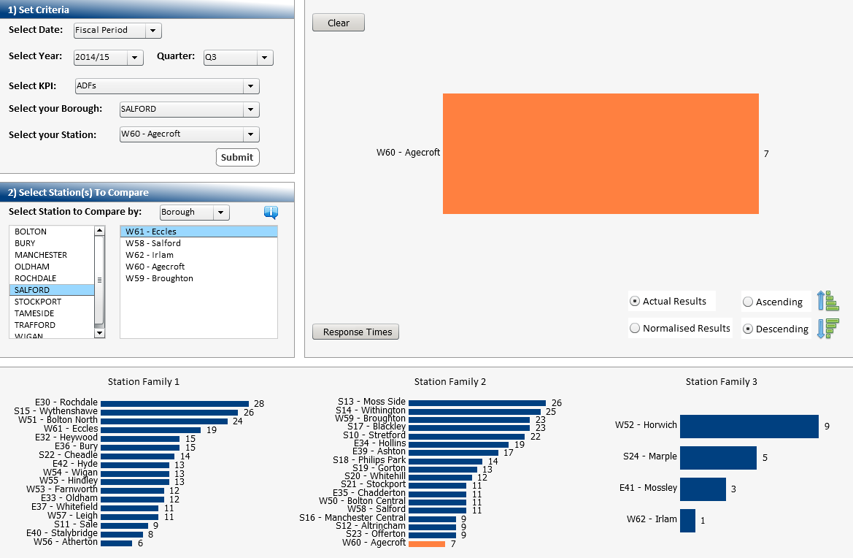

At the bottom of the screen, you can see the 3 Station Family groups.

The Station you selected is highlighted. (E.g. in this scenario Agecroft sits within group 2).

* Station Families are groups of Stations which have similar characteristics such as demographics, incidents etc, and are used to compare the performance of Stations which are more similar, rather than just those within the same Borough or geographical area.

Here is where you can choose which Station(s) you want to benchmark your Station with.

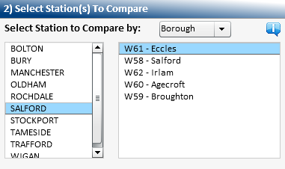

You can multi select from this list using the Ctrl Key. For this example Broughton, Irlam and Eccles Stations have been selected. The dashboard will refresh and data will be displayed for the selected Stations. (Your Station is highlighted in orang to make it easy to identify).

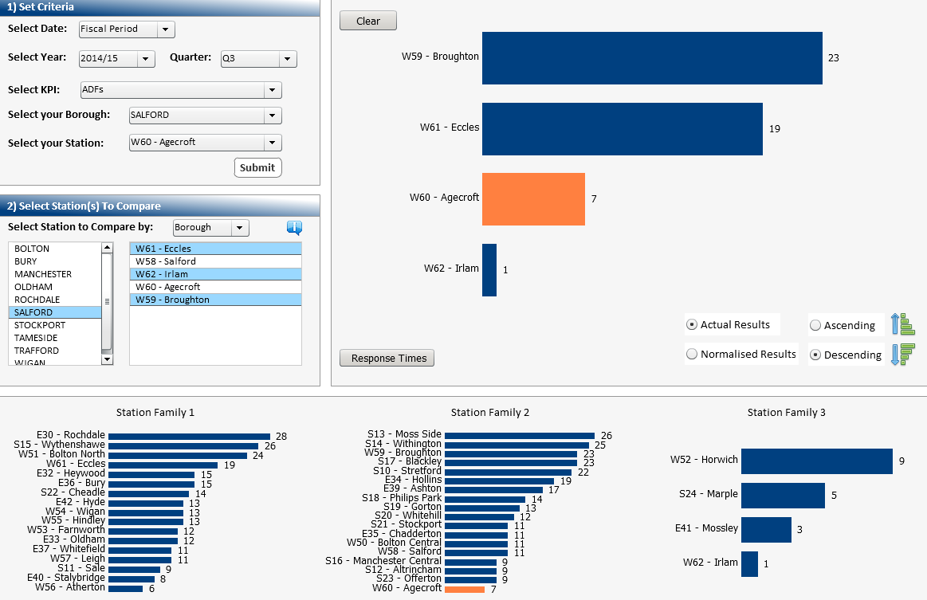

You can also view Mobilisation Performance for those selected Stations. Click 

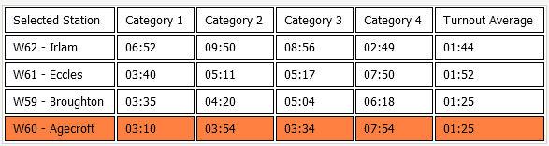

The table displays the Average Response Time (Travel) by Risk Category, for those selected Stations. It will also display the Average turnout Time for any mobilisation. To return to the previous view, click 

The data you see on the dashboard, automatically defaults to Actual Results (Number of Incidents) in Descending Order.

To show Relative Performance and allow a more realistic comparison to the other Stations, you would need to click the Normalised Results option.

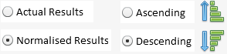

If you look at the refreshed data e.g. for Station Family 2, which is the group Agecroft Station belongs to, they’re no longer the best performing Station.

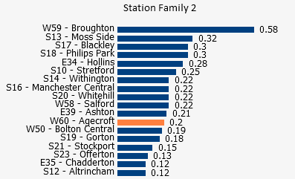

* In this example, relative performance is calculated by using:

Number of Incidents / Number of Dwellings x 10,000 Dwellings

If you were comparing primary fires, relative performance is calculated using the

population figure instead of number of dwellings.

You can also choose to view the data in Ascending Order.

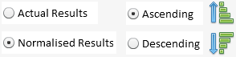

As well as comparing performance between those Stations within your Family group or Borough, you can select another Family group or any other Station(s). To do this simply click the relevant option from the list.

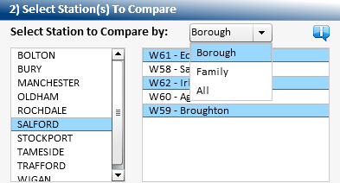

For this example ‘All’ has been selected. As you can see, all Stations appear on the dropdown.

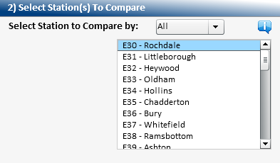

Again you can multi select by holding down the Ctrl Key. For this example Heywood, Hollins and Bury Stations have been selected. The dashboard will then refresh.

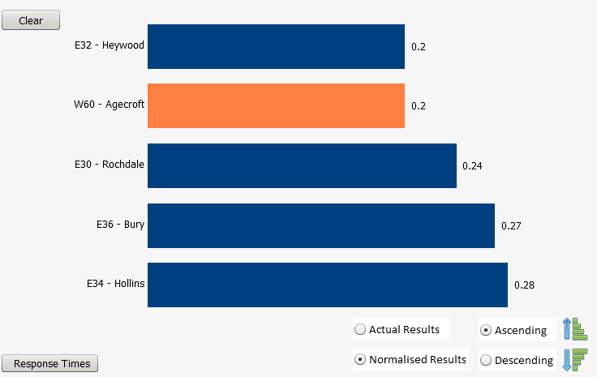

To return to the Home Page click 

## Station Scorecard

The Station Scorecard provides a single dashboard with relevant performance information at Station and where appropriate Watch level.

The scorecard is constructed across Prevention, Protection, Response, Public Value, People and Principles to support alignment of activities to the corporate purpose and aims.

The dashboard can be accessed from the Performance Tools menu on the Home Page.

Below is the default view of the Station Scorecard.

Here is where you choose your specific criteria.

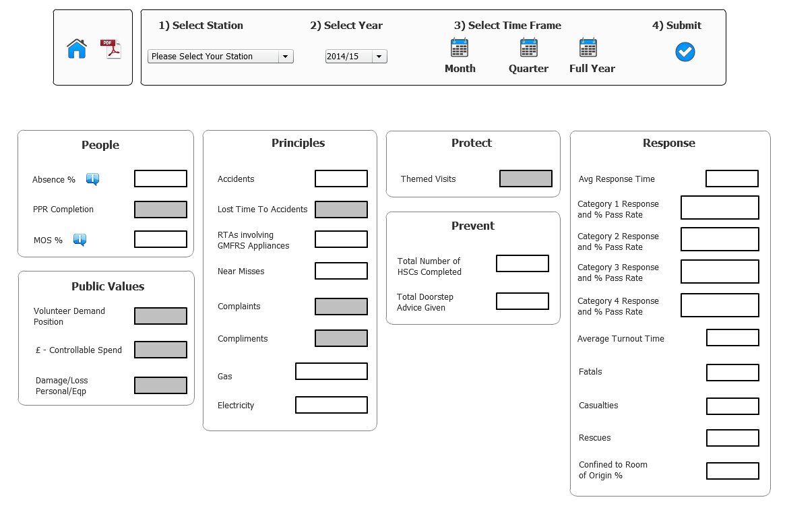

Click the dropdown to select your Station from the list. 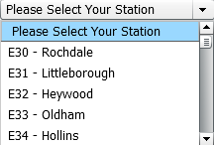 for this example I have selected W60 – Agecroft.

You then need to select the Fiscal year  and whether you want to choose a Month, Quarter or a full year view, clicking on the appropriate icon. I have selected Quarter 3.

Once selections have been made, click 

The dashboard will then be populated with information based on your specified criteria.

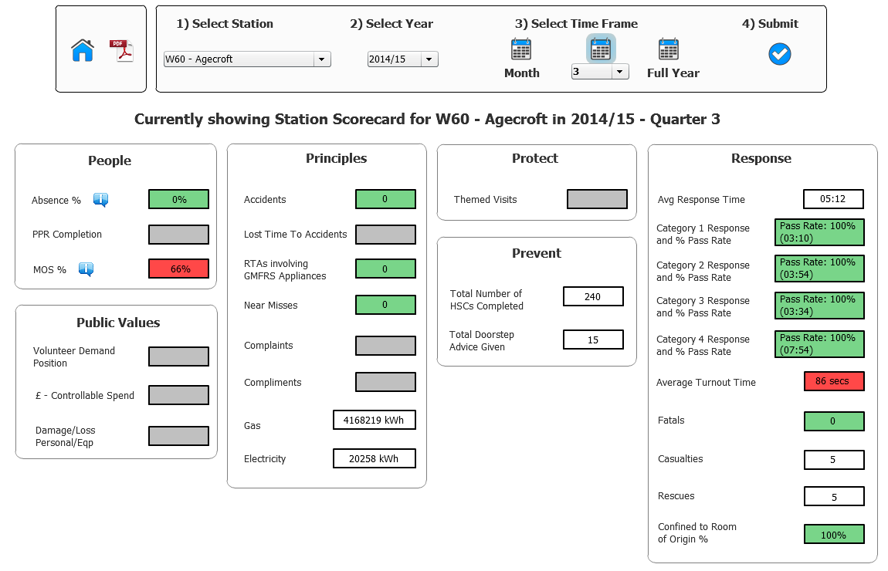

* Please be aware that some measures will not currently be populated as they are in development.

Where there is a target, these will show either **green** or **red** depending on whether the performance is on or off target. If there isn’t a target these will be shown in **white.** When you hover over the figures, it will display the **actual** target figure.

Example: 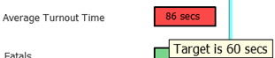

Some of the boxes when hovered over will become highlighted. The highlighted boxes contain Watch information.

To view Watch information, you would need to click on the title aim.

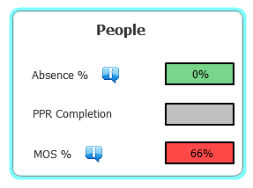

The box will expand and Watch information will display. (Where applicable).

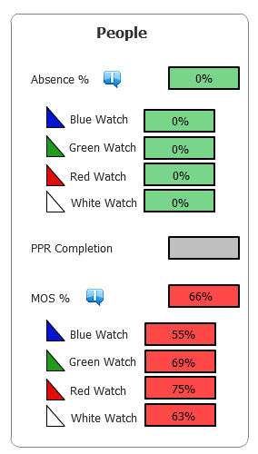

To collapse the box you would simply click on the title again.

If you need further clarity of the data, you can find further information by hovering over the information icon wherever you see it displayed.

Example: 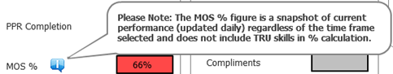

To return to the Home Page click 

## Printing the Dashboards

The system has the ability to print the information displayed on the dashboards.

This is available wherever you see the PDF Icon  and when clicked the following will display.

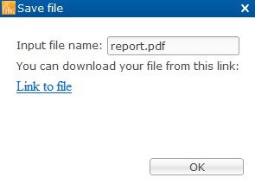

Click

The following message will display.



Click  this will then open up PDF with your dashboard.

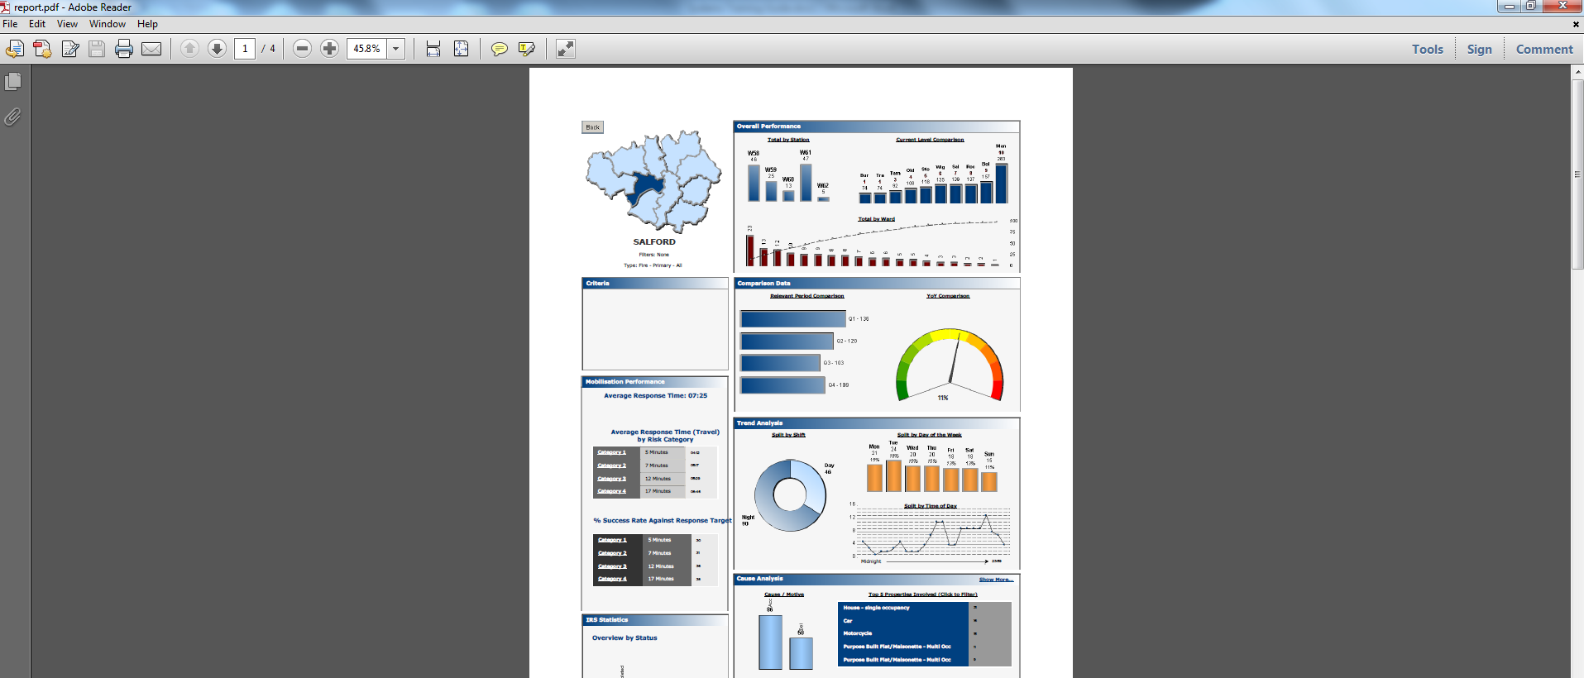

You would print in the usual way. Click  to close.



Click

You will be returned to the previous screen. To return to the Home Page click 

## Accessing the ‘Raw’ data

The dynamic dashboards, gives you the ability to drill down so you can access the ‘Raw’ data. To do this you would simply **double click** where you want to access the data from.

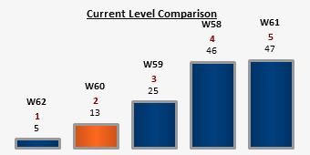

E.g. Double click to access the 13 Incidents for W60.

The following screen will display.

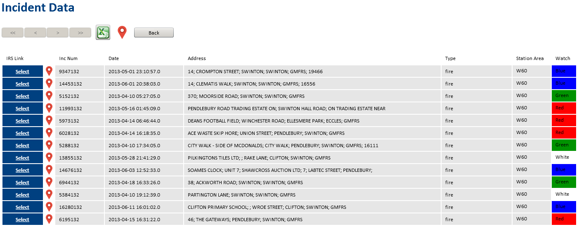

Here you will see a list of all the Incident Records, the Station Area and Watch will also be listed.

The chevrons  at the top of the screen allow you to scroll forwards and backwards through the pages of data, should you need to.

## Links to other Systems

Using the corresponding link from the Incident Data screen, you can open up an incident within the Incident Recording System. Click on the  button next to the incident you wish to view.

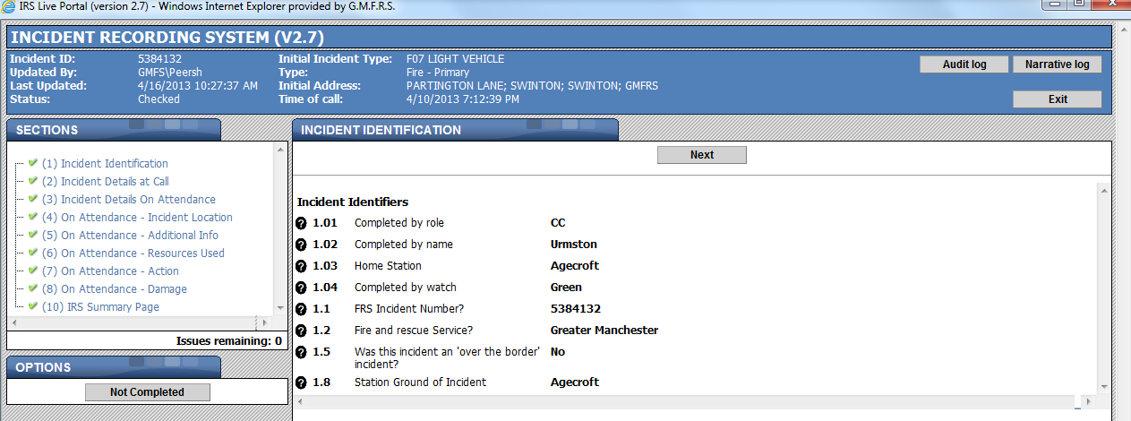

The incident will display, you can view the details in the usual way.

Click  to close. You will be returned to the previous screen.

* Where the data is displayed as a table, the raw data is accessed by **double clicking** onto the actual number. See below as an example.

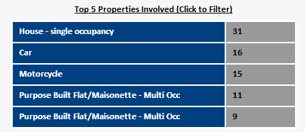

You can also see where the incident took place via google maps. This would be done by clicking the  next to the incident you wish to view. To see all the incidents plotted on the map you would need to click the icon at the top of the screen.

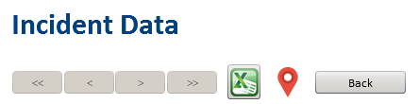

## Exporting Data

Information can also be exported into Excel.



From the list of Incidents click  when clicked the following will display:



Click

The following message will display.



Click  to open Excel. You will need to click 

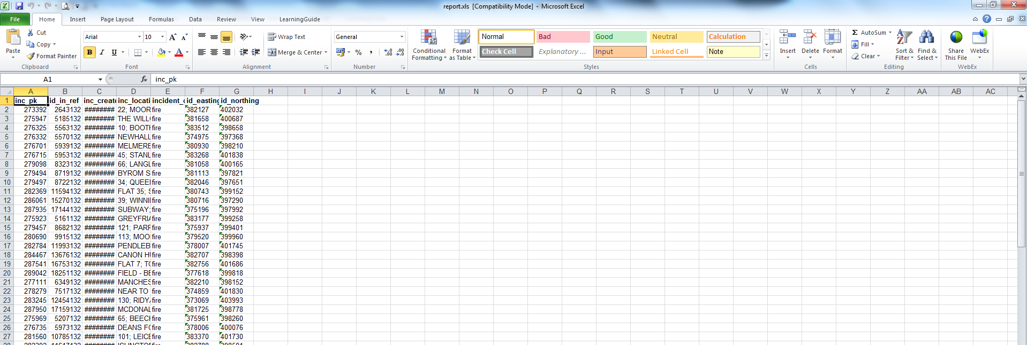

You will then be able to work with the Excel spreadsheet.

Click  to close. You will be returned to the previous screen.



Click

You will be returned to the previous screen. To return to the Home Page click 

# Help and Support

**Should you require any further help or assistance when using the Performance Portal contact a member of the** [**Systems Training**](mailto:systemstraining@manchesterfire.gov.uk) **and Support Team on**

**0161 608 4038 or**

[**performance@manchesterfire.gov.uk**](mailto:performance@manchesterfire.gov.uk)